A/R Statements Pro

Introduction
Thank you for using the A/R Statements Pro add-in, by Big Red Consulting.
We’ve written this document to ensure you have a smooth start when using the add-in, to provide an overview as well as detailed instructions, and to address frequently asked questions.
For best results, we recommend printing this document for easy reference and then reviewing it completely.

The A/R Statements Pro add-in works within Excel as an Excel Add-In. It creates a special menu to access its features, which are then used to create statements.
The add-in integrates with your QuickBooks company file by pulling data from QuickBooks and uses it to create letter-style statements in Excel. You can print statements for mailing or email them directly to your customers.

Please note:
QuickBooks is a registered trademark of Intuit, Inc.
MS Excel is a registered trademark of Microsoft, Inc.
The A/R Statements Pro and this document are copyrighted by Big Red Consulting.
Table of Contents
A/R Statements Pro 1
Introduction 1
Quick start Overview 3
Getting ready to create statements 3
What data is included on statements? 4
Custom Greeting Text 4
Transactions Detail Table 4
Optional Data 4
Address Fields 4
Custom Fields 5
Creating statements 5
Customizing your statements 6
Custom Columns for Detail tables 6
Subtotaling Details Tables 6
Logo and Signature fields 6
Custom Text messages 6
Custom Text 6
Text Formatting 6
Mail Merge Fields 7
Conditional Text 9
Conditional Text Illustrations 10
Aligning your statement data 11
Creating a mail merge summary table 12
Using the XL Email Manager with the A/R Statements Pro app 13
Mail Merge Table 13
Direct Statement Email 14
Some basics for managing the add-in 15
Installing the add-in 15
Loading the add-in in Excel 15
Trial Period 16
Purchase & Entering your Product Key 16
Un-Installing the add-in 16
Moving the add-in to another computer 16
FAQs 17
Troubleshooting 17
Getting Data from QuickBooks 17
Appearance of Statements 18
Select Screenshots 19
Sometimes a picture is worth 1000’s words… 19
Example statement 25

Quick start Overview
Once installed, you’ll see a custom Ribbon tab in Excel like this:
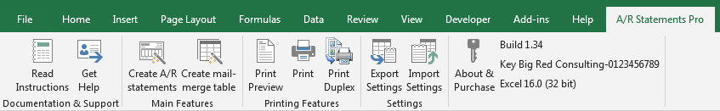
The tab has sections for the documentation, the main feature to create statements or a mail merge table, printing features, settings file features, and also displays the product build, your primary key, and your Excel version.
All or the app’s features are accessed from this tab (or a menu with similar item on the menu bar of older Excel versions.)
To create statements, make sure QB is running with your file open and then click the Create A/R Statements button on the Ribbon (or choose that option from the menu when using older Excel versions.)
The A/R statements app will first ask for your date range and other options and then pull data directly from QuickBooks. Next, you’ll be presented with an interview that lets you pick from many options. At the end of the interview it will then create the statements using these options.
If needed, you can go back and change your settings until your statements are just the way you like them.
Once they’re ready, then you can print them for mailing!

Getting ready to create statements
What do you need to create statements? Here’s a rundown:
- Excel should and QuickBooks should be installed on the same machine, with both applications running and with your company file open in QuickBooks.
- If you’ll be emailing statements, you need the XL Email Manger (offered on our site) installed and configured.
- Recommended:
  - Log into QuickBooks as the Admin user to ensure you have rights to all needed data.
    - If you need to switch company files before creating statements, do that and then restart QuickBooks
  - Switch QuickBooks to single user mode to increase performance.

You can use windowed envelopes (optional and highly recommended for mailing.) Have them on hand so you can test alignment of the address fields.
This app is designed to create statements that can be tri-folded and stuffed into #10 windowed envelopes, so no labels or manual addressing is required. Customers have pointed out that the small additional cost for windowed envelopes more than makes up for the cost of computer labels, reduces the time spent matching the labels to statements, and eliminates the possibility of sending a statement to the wrong customer.

What data is included on statements?
This A/R Statements Pro app reads QuickBooks transaction data from your company file. From that data it creates your statements. Transactions including Invoices, statement charges, payments, credit memos, and any other transaction that impacts A/R accounts are included. You can also optionally include sales receipts.

Custom Greeting Text
You can include two sections of custom text on your statements to make them look more professional and more like letters to your customers. This text can use special key words that are replaced per customer such as [Name] and you can format it in other useful ways.

Transactions Detail Table
The app will create a table of details with the data for the period you specify. It also includes a Balance Forward line, the total statement amount, and optionally the sum of any future activity and the ending customer balance.

Optional Data
When you start the process to create statements, you can include additional transaction types and data fields in the data returned from QuickBooks.

You can optional include sales receipt details on your statements. Sales receipts don’t have an open balance, but you may still want to include them on your statements for customer accounts that include both invoices and sales receipts. Or, you may even want to create statements for customers with only sales receipt (cash) transactions.

Optional data fields include various address fields and two types of custom fields.

Address Fields
The customer billing address is always included in the data returned from QuickBooks.

In addition, there are six optional sets of address fields you can pull from QuickBooks:
The customer shipping address fields parsed into address parts.
The customer shipping address block fields 1 – 5 as they appear on the customer record.

Each transaction’s billing address fields parsed into address parts.
Each transaction’s billing address block fields 1 – 5 as they appear on the transaction.

Each transaction’s shipping address fields parsed into address parts.
Each transaction’s shipping address block fields 1 – 5 as they appear on the transaction.

Each set of parsed address fields returns the address pats Salutation, Salutation 2, Street 1, Street 2, City, State, ZIP, and Country. (Note that a single 5-row address in QB cannot have all of those parts, since that would be a 6-row address.)

Transactions like invoices and credit memos which have address fields can have a different address than the customer billing addresses or one of the shipping addresses. In this case the transaction address are useful to see where a transaction was actually billed or shipped.

Custom Fields
The first type of custom field data that can be returned are the custom field values as stored on your customer records. There are 15 fields returned. These are generically labeled “Custom 1”, “Custom 2”, and so on through “Custom 15”. It is up to you to review the “Data” worksheet to figure out which generic labeled column contains the desired data.

The second type of custom field data is that data you’ve actually entered on your transactions. These fields can be from your customers or your items. These fields are specified by the name you’ve given them in QuickBooks.

Creating statements
To start the process to create statements, choose “Create A/R statements” from the menu or the Ribbon
You’ll be presented with a wizard that helps you pull data from QB and create your statements. In the wizard each slide displays a set of choices, which are remembered from session to session.
The first slide of the wizard helps you get QuickBooks data. Explore the Options button for, well, options!
Subsequent wizard slides ask for the customers to include, what columns of data you’d like to show in the detail area of your statements, and other filters and options.
Note: After creating statements and reviewing the results, you can re-create statements using the data already pulled from QuickBooks or you can get data again, perhaps for a different date range or after updating QuickBooks data.
To create statements with existing QuickBooks data, make an existing statement workbook visible/selected when you start the process to create statements. Then, use the Skip button when you’re presented with the first wizard dialog window.

Customizing your statements

Custom Columns for Detail tables
You can show any of the available columns returned from QuickBooks in your transaction data tables. The app defaults to a set of columns the first time you use it which you can change as desired.

Subtotaling Details Tables
You can subtotal the detail data table on most any available field. So for example, instead of including the Account column in your table, you group and subtotal by account. When you subtotal, the transaction data is automatically sorted and grouped by the field selected to subtotal, Amount, Open Balance and Ending Open Balance columns are subtotaled.
You may elevate some records you are sorting on to the top of the list. To do this, click the little sort button next to the subtotal by pick list and then select the record or records you want to appear first in your transaction tables.

Logo and Signature fields
You can specify a logo and signature image files to be included on your statements. Select these options on the Logo & Signature Tab.
There you can also scale/shrink the graphics for the desired appearance on your printed statements.

Custom Text messages
The app includes three powerful yet simple custom text fields you may include on your statements. These are the Opening Paragraph(s), Closing Paragraph(s), and Footer fields. In these fields, you can specify custom text, custom text formatting, “mail merge” fields, and conditional text based on mail merge fields.

Custom Text
The three custom text fields have default values which you can change to suit. In addition to regular text, you can modify your text using formatting, add special mail merge fields in [brackets], and make sections of text conditional.

Text Formatting
You can format text within these fields using three html-like code pairs that surround the target text: You can bold, underline, and italicize portions of your text messages in this way. Use these keywords:
- To bold text, use <b> and </b>
- To underline, use <u> and </u>
- To italicize, use <i> and </i>
For example, if you specify a sentence like this:
I like to include <b>bolded</b>, <u>underlined</u>, and <i>italicized</i> text from time to time on my statements!
Then it will appear on your statements like this:
I like to include bolded, underlined, and italicized text from time to time on my statements!
If you use <b>, <u>, or <i> and don’t include the closing </b>, </u>, or </i>, then the rest of the text will be formatted accordingly.

Mail Merge Fields
Mail merge fields are special values surrounded with square brackets. When you use them, the field is replaced in the text with the value appropriate for each customer based on your QB data. For example, if you enter [Name] as part of your text field, the customers name will be replaced on each statement with that customer’s name.
Mail Merge key words
Key words come from two places.
First, most every column of the returned data can be used as a key word. The most useful of these columns are those related to the customer overall and not their individual transactions.
Second, the special calculated fields below can also be included in your text.
You can see a complete list of available key words from a pick list on the Layout & Message slide. Use any of these data fields in your text.
Calculated Mail Merge Fields:
Name | Meaning
[Any Column Name] | Here, replace Any Column Name with a column name from the returned data. Column names are the values in the first row of the “Data” worksheet, which you will see after getting data from QuickBooks.
[Salutation] | This is a special field derived from your data. It uses the ‘best-guess’ for a salutation by gleaning data from several available fields. The first found non-blank value is used, found in these returned columns, in this order:  - Transaction Name Address To,  - Transaction First Name & Transaction Last Name (both must be non-blank)  - Transaction Company Name  - Transaction Name  - Detail Name
[First Last] | The Customer’s First and Last name as entered on the customer record.
[Addressed To] | The first row of the Bill To address block, usually the recipient’s name.
[Name] | Customer Name
[Start Date] | The start date for the data retrieved from QuickBooks, or the secondary start date if using the “Show transactions for these dates only” option on the Filters tab.
[End Date] | The end date for the data retrieved from QuickBooks, or the secondary end date if using the “Show transactions for these dates only” option on the Filters tab
[Primary Start Date] | The start date for the data retrieved from QuickBooks.
[Primary End Date] | The end date for the data retrieved from QuickBooks.
[Company Name] | Your company legal name (not the customer.)
[Company ID] | Your Federal Tax ID (not the customer.)
[Bill To Name] | The Bill To company name (the first row of the company address.)
[Balance Account] | The customer’s ending balance including any transactions after the statement date.
[Balance Due] | The total balance due as of the statement date.
[Balance Current] | Current (not overdue) balance as of the statement date.
[Balance Overdue] | The overdue balance as of the statement date.
[Balance Future] | The sum of open AR transactions after the statement date.
[Balance over 30 days past due] | The portion overdue balance that is over 30 days past due.
[Balance over 60 days past due] | The portion overdue balance that is over 60 days past due.
[Balance over 90 days past due] | The portion overdue balance that is over 90 days past due.
[Balance 1 to 30 days past due] | The portion overdue balance that is 1 to 30 days past due.
[Balance 31 to 60 days past due] | The portion overdue balance that is 31 to 60 days past due.
[Balance 61 to 90 days past due] | The portion overdue balance that is 61 to 90 days past due.

Conditional Text
The conditional text feature works with mail merge fields. It allows you to make parts of your text messages display on statements only if all of the mail merge fields within the conditional text sections return non-empty or non-zero values for amount fields, OR if they all return empty or zero values
To specify conditional text, surround the target text with the tags <cutEmpty> and </cutEmpty> or <cutNotEmpty> and </cutNotEmpty>.
For example:
This text will be removed if the statement balance is 0.00:
<cutEmpty>Your amount due is $[Balance Due].</cutEmpty>
This text will be removed if the statement balance is not 0.00:
<cutNotEmpty>No payment is required because your account balance is $[Balance Due].</ cutnotempty>

If the Account Balance is 0.00, then the entire section of text is omitted.
If the conditional text stands alone as its own paragraph, then for best formatting you may want to put the tags on the preceding or following rows. This will avoid a large empty space on the resulting statement.
Examples:
This text will result in three blank rows between paragraphs if the open balance is 0.00:
Your Balance due is [Balance Due].

<cutempty> Your Account balance is [Account Balance].</cutempty>

We look forward to your continued business.
This text will result in one blank row between paragraphs:
Your Balance due is [Balance Due].
<cutempty>
Your Account balance is [Account Balance].
</cutempty>
We look forward to your continued business.
This text will result in one paragraph, where is no value:
Your Balance due is [Balance Due]. <cutempty>
Your Account balance is [Account Balance].
</cutempty>We look forward to your continued business.
This text will result in one paragraph:
Your Balance due is [Balance Due].<cutempty> Your Account ending balance is [Total Open Balance].</cutempty>We look forward to your continued business.
Notes:
-If there is no [keyword] between the conditional tags, the text will always remain.
-If there are two or more key words between the conditional tags, then if any are blank, all of the text is removed.
- If an opening tag is not followed by a closing tag, and there are no closing tags there is no effect on the text. If there are multiple opening tags followed by a closing tag, the first opening and first closing tag are paired and all the text between is considered together and omitted together.

Conditional Text Illustrations
Here are some examples of how you might use conditional text on your statements

Thank you for your business.
Your statement balance as of [End Date] is $[Balance Due]. <cutempty> Also, you have an overdue balance of [Balance Overdue]. Please resolve this matter promptly by paying your balance on receipt of this statement.</cutempty>

Thank you for your business.
Your statement balance is $[Balance Due].
<cutempty>Your account is overdue! $[Balance over 60 days past due] is over 60 days past due. Please resolve this matter promptly by paying your balance on receipt of this statement.</cutempty>

Thank you for your business!
<cutnotempty>No payment is required because your account is balance is $[Balance Account].</cutnotempty>

Thank you for your business!
<cutempty>Your your statement balance of $[Balance Due] includes an overdue balance of $[Balance Overdue]! </cutempty><cutempty>Please pay your statement balance of $[Balance Due] upon receipt unless your account balance is less than your statement balance.</cutempty><cutnotempty>No payment is required because your ending statement balance is $[Balance Due].</cutnotempty>

Aligning your statement data
The A/R Statements Pro app can be used to print or email statements. When printing, it is intended to create statements which can be tri-folded and stuffed into windowed #10 envelopes. When you do this, you don’t need to manually address your statements, or even print and affix mailing labels.
To fine-tune alignment settings, we suggest creating a trial run where you print one statement from those created. To do this, first create statements as usual. Then choose File | Print and in the Print Range fields enter pages 1 to 1. As a result only one (or part of one) statement will print. Take this statement, Z-fold it, and check it for alignment with your windowed envelope stock. If needed, change settings then re-create statements and print again.
Custom Alignment Settings
Note: These adjustments impact statements about to be created, not any exiting statement worksheets.
Intro Gap: This is the vertical space between the customer address and the intro paragraph text. The setting is found on the Message tab.
Align Address tab
This tab lets you move both your company address and customer addresses left or right, and up and down to match your windows envelopes.
Margins
After making the adjustments above, if your address fields don’t align, also try making adjustments to your statements using the Margins section on the Options & Create tab of the create statements interview.

Creating a mail merge summary table
In addition to creating statements directly in Excel, you can also create a mail-merge summary table for use outside of Excel.
This option is suitable for creating mailing labels or statements for your customers in another application such as MS Word, and for uses as a data source for other needs.
To start the process to create a mail merge table, pick the option “Create mail merge table” from the custom menu or the Ribbon.
The resulting interview to create your mail merge table is similar to the Create Statements wizard, asking only applicable questions. Some settings are shared with the Create Statements wizard.
The mail merge feature creates a new workbook containing a worksheet of data where each customer record occupies one row on the worksheet. It contains information such as the name and address, activity, and both HTML and text fields containing tables of transaction data similar to those included in Excel-based statements.
Once this worksheet is created and saved, you can use it as a data source in MS Word to create mail merge letters or to email the data. To start that process in Word 2003, choose Tools | Letters and Mailings | Mail Merge. Later versions of Word have different steps.
When you install the A/R Statements Pro app, an example Word doc that matches the mail merge data is also installed. It is named “Statement Mail Merge Template”. Using MS Word, you can use it as a starting point for your mail merge process.

Using the XL Email Manager with the A/R Statements Pro app
The XL Email Manager can be used two ways with the A/R Statements Pro app.
- First, it can process data produced using the mail merge table option.
- Second, it can email statements directly to your customers.

Using both of these options, you can create statements for Customers that include thank you messages as well as a table of each Customer’s activity for the period.

We recommend using the latest release of the XL Email Manager, available from our site.

Mail Merge Table
To use the XL Email Manager with the A/R Statements Pro app, get and install the latest build of the XL Email Manager from our site and then use the option from the A/R Statements Pro menu to create a mail-merge table. When you do so, a worksheet that will work with the XL Email Manager is created. It includes customer names and email addresses as well as several special fields that include each Customer’s detailed history for the period.

Most of the fields are self-explanatory and you can use instructions in the XL Email manager’s documentation to use them as email merge fields. These include fields like Salutation and first and last names.

Several fields are special. These contain the detailed transaction history for each Customer based on the data from QuickBooks.

details_HTML – This field contains an HTML table of the Customer’s activity, similar to what appears when you create statements to print. If you include the field in your HTML email body description, you’ll see a formatted table when you review the email in an email program or web service.

details_TEXT – This field contains a text table of the Customer’s activity. It is useful for text email, which is not usually seen by customers unless you don’t create an HTML email body or if the customer has a text-only email reader.

Direct Statement Email
You can now also email statements which look just like the ones you print. Here’s how it works:

Set up
1. Install, configure the XL Email Manager so you’re sure it’s working: Supply it with your email account information such as your user name and password as well as server address just as you might when setting up another email client. Then test sending email directly from the XL Email Manager. Once it is working, then it is ready to be used with the A/R Statements Pro app.

2. Start the process to create statements and pull data form QuickBooks. Proceed to the Customers tab. If you are in trial mode, the app will automatically email only those Customers with email addresses. Once registered, you can manually select customers, including an option to auto-select those with or without email addresses. You can use this filter to send email to one group of customers and mail statements to the rest who don’t have an email address.

3. Enable the option to email statements on the “Email” tab of the wizard (don’t forget all the other options as well). It provides a place to enter the subject and the body of the email, as well as the “From” name and address (which should match the email account set up in the XL Email manager) and other options:

CC me: Check this box and you’ll receive a copy of each email sent to your customers.
Email statements to the “From” address…: This option replaces the destination address with the “from” address, so that you can send the statements directly to yourself, for reasons such as testing the process.

Understanding Attachments
When emailing, select one or more of the attachment options, and each customer’s statement will get the attachment types selected:
PDF: Creates a standard PDF file and attaches it. The PDF option is available with Excel 2007 or higher (older versions can not create PDF files automatically)
XPS: Creates a standard XPS file and attaches it. XPS is the format used by the Microsoft XPS Document Writer, and all or nearly all Windows machines come with this driver preinstalled, so Windows users should always be able to read this file format.
XLS: Creates an Excel workbook containing one customer’s statement, for attachment to an email.

Some basics for managing the add-in
This is an overview of various utility operations you may want to complete when using the add-in. The later sections in this document cover the steps for using the add-in.

Installing the add-in
If you downloaded the installer and ran it, installation is complete.

Loading the add-in in Excel
If you may manually load this add-in from within Excel if the installer was unable to load it or it was manually unloaded. This is usually a one-time process. Once loaded, each time Excel starts the add-in will be available until you unload it:

To load the add-in, first start Excel & make sure a workbook is open (one usually opens when you start Excel.)
Excel 2010 - 2016:
1. Select File, then Options from Excel's menu.
2. In the Options dialog, select Add-ins.
3. At the bottom of the add-ins pane, select Excel Add-ins and press Go.
4. When the Add-ins dialog opens, click Browse and navigate to the folder where you installed the add-in (noted below.)
5. Select the *.xla file and then OK to close the dialogs.

Excel 2007:
1. Click the Microsoft Office Button and then click Excel Options.
2. Click Add-Ins and then in the Manage box select Excel Add-ins. Click Go.
3. In the Add-Ins available box, click Browse... and navigate to the folder where you installed this add-in (noted below.)
4. Select the *.xla file & then OK to close the dialogs.

Excel 2000 to 2003:
1. In Excel choose Tools | Add-ins from Excel's menu.
2. Click Browse & navigate to the folder to which you installed this add-in.
3. Select the *.xla file & Press OK to close the dialogs.

At this point, you should see this add-in listed in the Add-In dialog, with a checkmark next to it. Press OK to close the dialog, which will load the Add-In.
In Excel 2007 - 2016, you’ll see the add-ins access points from the Add-Ins tab. In Excel 2000 – 2003 you’ll see a new menu item appear just to the right of Excel’s help menu.

Trial Period
Once loaded, the app is in “trial” mode. In trial mode, most features are available, but there are limitations to the number of statements that can be created.

Purchase & Entering your Product Key
To purchase the add-in, select About & Purchase from its menu. Click the Purchase button and you’ll be taken to our website to a starting point to make your purchase. At the end of the purchase, you’ll receive an email with your receipt and product key.

To enter either your key, choose About & Purchase from the A/R Statements Pro menu in Excel, enter the key into the Product Key field, and then press the Accept button to unlock the product.

Un-Installing the add-in
To uninstall the add-in, run the uninstaller from the windows Add/Remove Programs control panel, or Programs & Features control panel (Windows 7+)

Moving the add-in to another computer
To move the add-in to another computer,
- Locate your key code. If you don’t have a copy of the email we sent, you can copy the key out of the About & Purchase dialog.
- Install the app on the new computer.
- Enter your product key on the new computer

FAQs
No statements are created
Make sure your ‘filters’ don’t exclude all of your transaction data.
For example, make sure you select all the accounts used on transactions, all the customers, and have not set a ‘floor’ amount to exclude small transactions. Also, make sure the date range for the statements includes the dates of the data actually requested from QuickBooks in the current statement workbook.

Only three statements are created
Check to make sure the “Sample Mode” option on the Filters slide of the wizard is not selected. If it is, de-select it and try again.

Can I create statements again without connecting to QuickBooks?
Yes, with a workbook created by the app open and selected, you can start the process to create statements and then use the “Skip” button to proceed.

I upgraded Excel and the add-in is gone
Each version of Excel has its own list of loaded add-ins. MS calls this a feature. So, when you upgrade excel, none of your custom add-ins will be loaded. The easiest fix to this is to rerun the installer. If you don’t have it, you can download it again from www.bigredconsulting.com

Troubleshooting
There are two basic problem areas we’ll cover: Problems getting data from QuickBooks and problems with the creation of appearance of the statements when the connection is working fine.

Getting Data from QuickBooks
There are several possible issues seen when connecting and getting data from QuickBooks. The basic issue is that the add-in cannot connect to QuickBooks and retrieve data. These are relatively common, and can usually be solved by fixing QuickBooks.

You may see messages that indicate one of these issues:
- QuickBooks is not running or cannot be found
- No data is returned from QuickBooks
- Data is returned, but not all of the data in the date range is returned
- Get an Active X error.

For each of these, here are the steps to solve the issue:

QuickBooks is not running or cannot be found
- Repair the QuickBooks installation from the Windows Programs or Program & Features control panel.
- Restart your machine.
- If that does not work, uninstall and reinstall QuickBooks.

No data is returned from QuickBooks
- Make sure you have applicable data in QuickBooks in the requested date range.
  - Data that is retrieved includes Sales Receipts, Invoices that are paid in the period, Deposits where you record income directly on the deposit, Credit Memos that are applied to something (either an Invoice or a refund) and optionally Journal transactions.
- Rebuild the QuickBooks data file from the QuickBooks File | Utilities menu.

Data is returned, but not all of the data in the date range is returned
- Rebuild the QuickBooks data file from the QuickBooks File | Utilities menu.

Get an Active X error.
- Repair the QuickBooks installation from the Windows Programs or Program & Features control panel.
- Restart your machine.
- If that does not work, uninstall and reinstall QuickBooks.

For more troubleshooting, see Connecting to QuickBooks - Troubleshooting

Appearance of Statements
Fonts appear too small when printing
Fonts may appear smaller than usual when printing if the statement is so wide that Excel must scale it down to fit on the printed page (fit to one page wide.) To change this and reduce the statement width, try these tactics:
- Make the table font smaller than the rest of the statement. Do this in the wizard as you create statements.
- Make the text font for the paragraphs of text larger, while leaving the table font as-is.
- Remove one or more columns from the data table in order to make it narrower.

Select Screenshots

Sometimes a picture is worth 1000’s words…
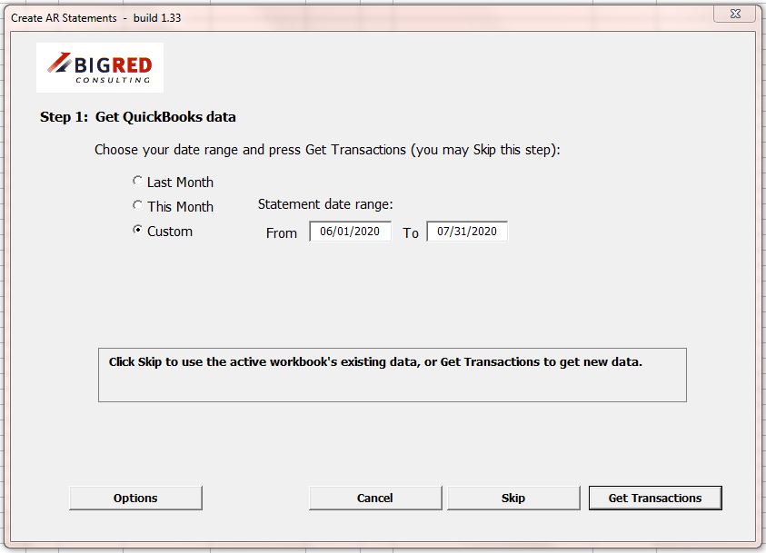
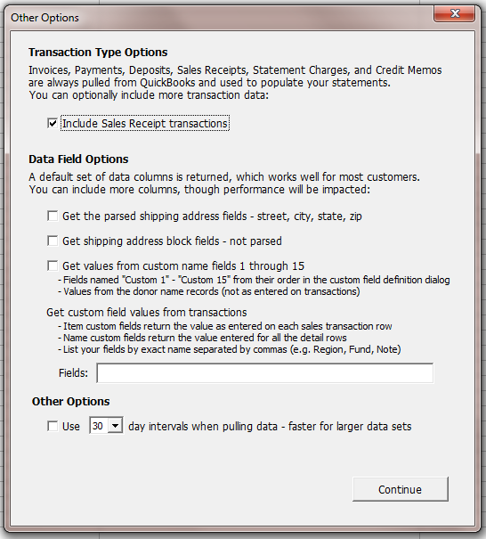
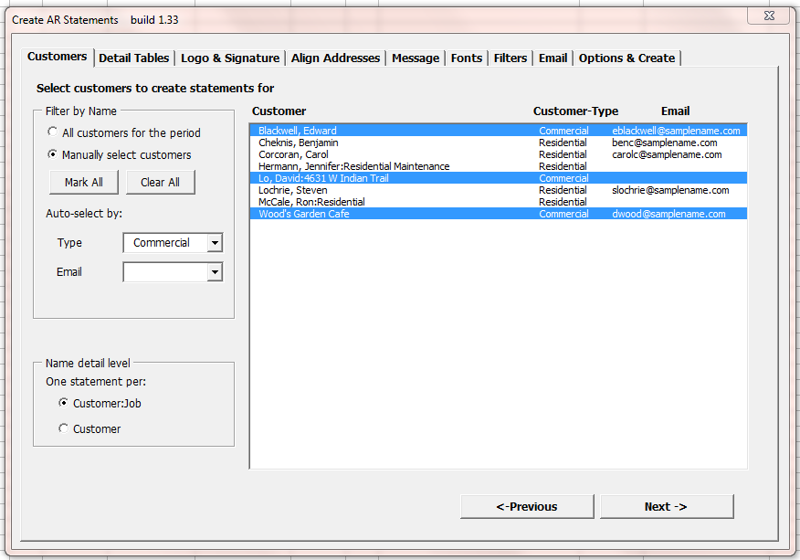
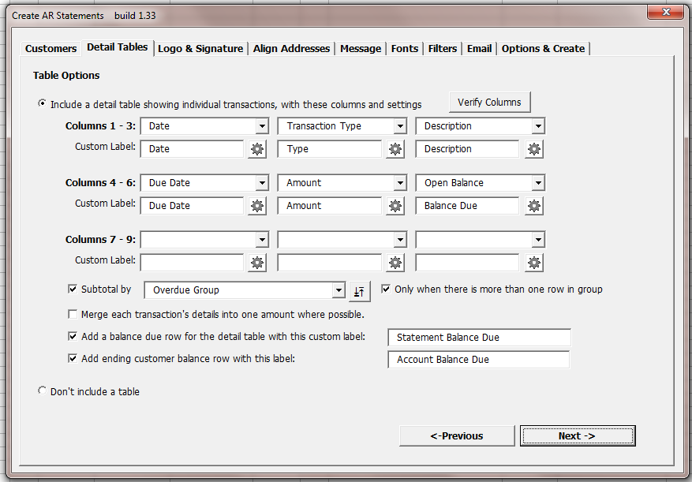
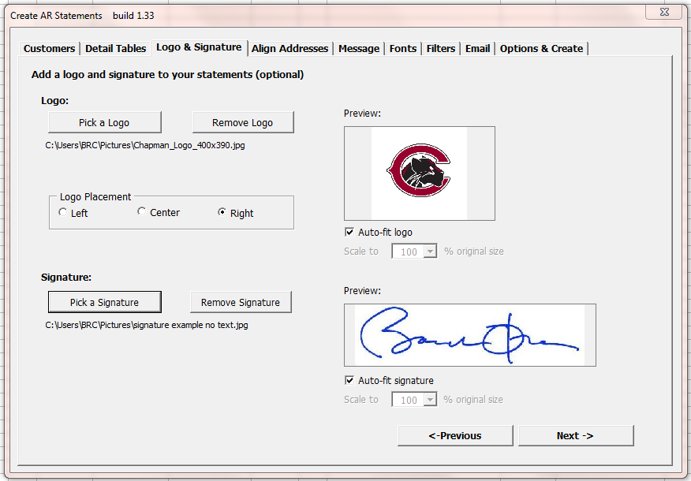
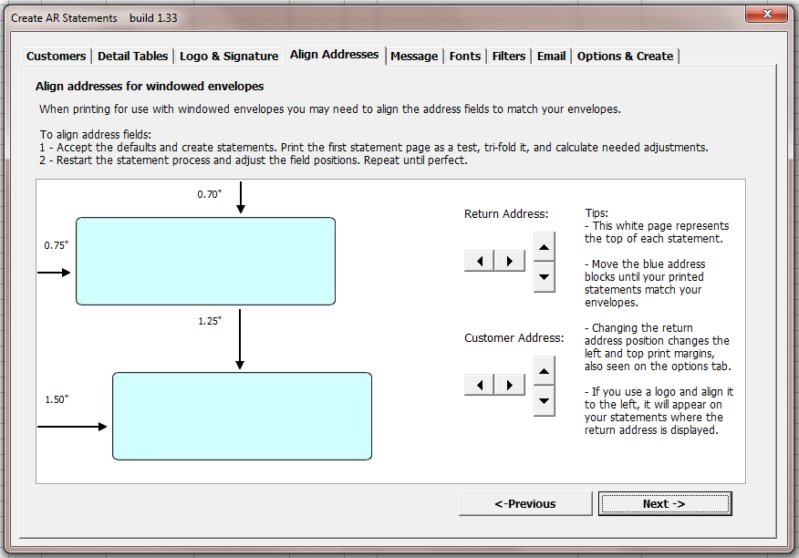
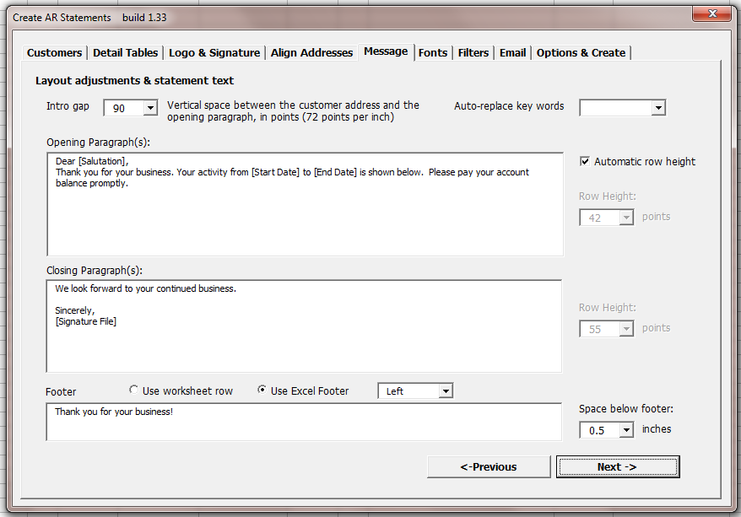
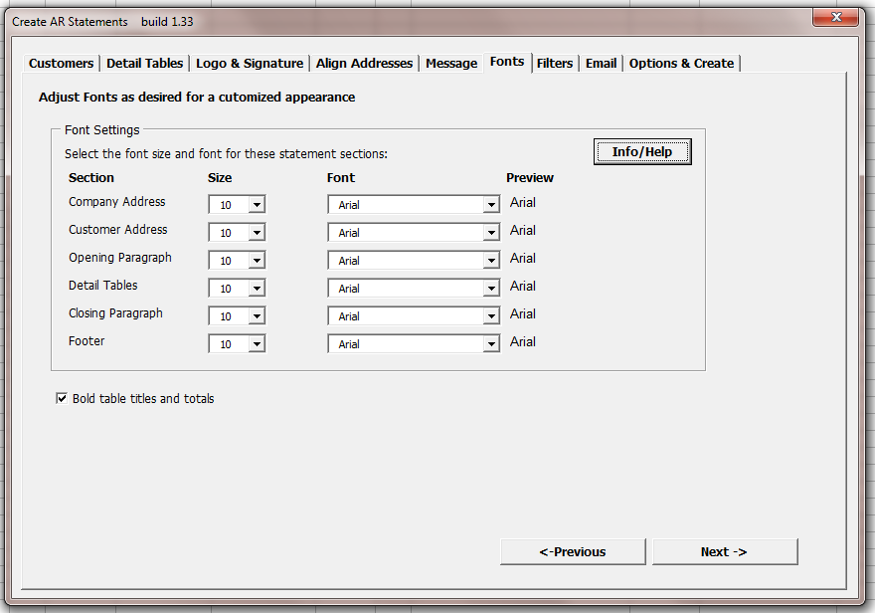
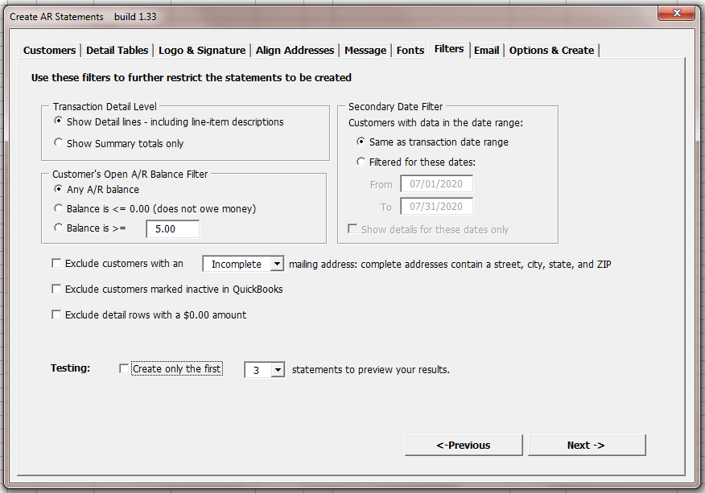
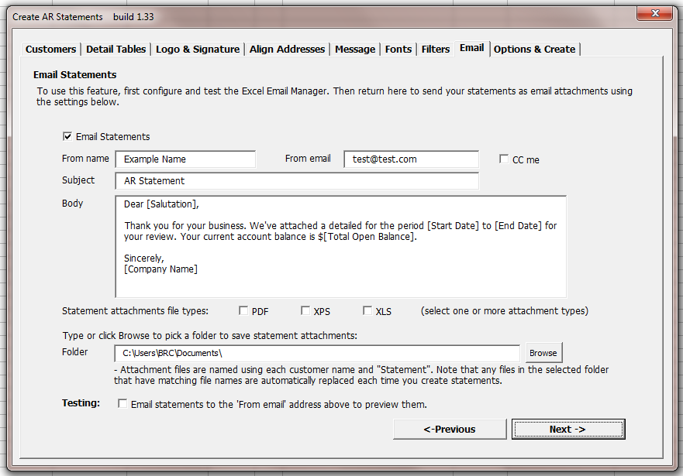
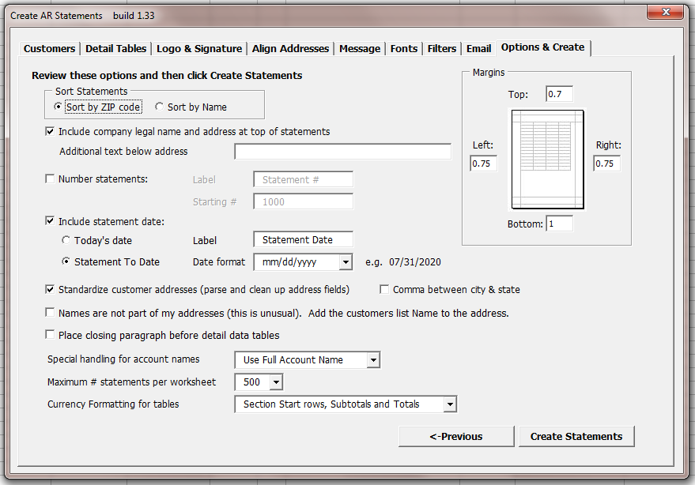

Example statement
Many options are available to modify statements. Here an example using the default settings:



