
Donor Statements – QB Online
Introduction
Thank you for using the Donor Statements add-in, by Big Red Consulting.
We’ve written this document to ensure you have a smooth start when using the add-in, to provide both an overview as well as detailed instructions, and to address frequently asked questions.
For best results, and to make the best use of its various features, we recommend printing this document for easy reference and then reviewing it completely.
The Donor Statements add-in works within Excel as an Excel Add-In. It creates a special Ribbon tab to access its features, which is used to create donor statements.
It uses the data from several reports exported from QuickBooks to create letter-style statements in Excel. You can print paper statements for mailing or email them directly to your donors (when also using our Excel Batch-Email Manager add-in.)

Please note:
QuickBooks Online is a registered trademark of Intuit, Inc.
Microsoft Excel is a registered trademark of Microsoft, Inc.
The Donor Statements, the BRC Excel Batch-Email Manager, and this document are copyrighted by Big Red Consulting.
Table of Contents
Quick start Overview 3
Getting ready to create statements 3
Creating statements 4
Creating & Exporting QuickBooks Reports 4
Create and Save Reports 4
Run & Export Saved Reports 8
Creating Statements – Selecting Report Files 9
Customizing your statements 10
Account Filter 10
Item Filter 11
Donor Filter 11
Other Filters 12
Contribution Tables 13
Message Text 14
Logo and Signature Options 15
Font Selection 15
Address Alignment - for windowed envelopes 16
Delivery – Print or Email 16
Statement Options 17
Custom Text Features 20
Text Formatting – bold, italic, and underlined 20
Auto-Replace Key Words 21
Conditional Text 22
Use First 23
Use First and Conditional Text together 23
Aligning statement data 24
Printing statements 25
Emailing Statements 26
Email Statements using the Excel Email Manager 26
Basic set-up 26
Email Settings - Field by Field 27
Mail Merge Table 28
Creating a mail merge summary table 28
Housekeeping - Installing & Purchasing the Donor Statements 29
Install the add-in 29
Load the App as an Excel add-in 29
Trial Period 29
Purchase & Enter your primary product key 29
Moving to a new computer 30
FAQs 31
Troubleshooting 31
Appearance of Statements 31
Example Statement 32

Quick start Overview
To create donor statements, you’ll first create several reports in QuickBooks Online and then export them. Then from withing Excel, you’ll use the Donor Statements to create your statements.
In Excel, the Donor Statements custom Ribbon tab looks like this:
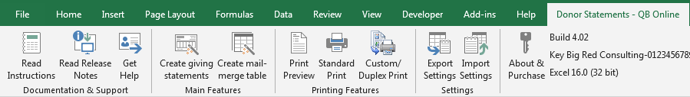
The features are orgainized in order from left to right in the order you might use them:
- Documentation & Support: A link to these instructions, to read the release notes, and one to submit a support request. The Read Relase Notes icon will change to “Get Build”, if there is a newer build/release available!
- Main Features: Create statements and/or a special mail merge table, perhaps for use with Word.
- Printing Features: Shortcuts to Excel’s Preview and standard printing features and the Custom/Duplex printing feature just for statements.
- Utilitiy sections to export/import your settings, to purchase and enter your product key, and a display of your current build, your primary key, and the Excel version you’re using.
When creating statements, you will first create and export several reports from QuickBooks. As you create statements, the Donor Statements tool will import/process them and then you’ll be presented with a window that offers options & settings to help you create statements to suit your needs. Once configured, statements are created using your custom settings.
If needed, you can create statements over and over, each time refining your settings, without reprocessing the QuickBooks reports. You can do this until your statements are just the way you like them.
Once the statements are as desired, you can either print or email them. If printing, you can use the special Custom/Duplex print feature to save paper.

Getting ready to create statements
What do you need to create statements? Here’s a rundown:
- Your donation data is entered in QuickBooks in a way the Donor Statements will recognize it. Basically, this either using sales forms like Sales Receipts and Invoices or directly as Deposits.
- If emailing statements, Excel Batch-Email Manager (offered on our site) is installed and configured.
- If printing statements, we recommend using windowed envelopes (which is optional.)
The add-in is designed to create statements that can be tri-folded and stuffed into #10 windowed envelopes, so no labels or manual addressing is required. This reduces the time spent matching the labels to statements and eliminates the possibility of sending statements to the wrong donors.

Creating statements
The process to create statements can be divided into two steps: Creating and processing the special QuickBooks reports and then in Excel creating the statements from those reports.
This Donor Statements tool uses the donation data included on several reports created in QuickBooks and creates a new Excel workbook with your data, reformatted on several worksheets. From that data then creates your donor statements. Use the following instructions to create and export the QuickBooks reports.

Creating & Exporting QuickBooks Reports
Use the instructions below to create, save, and then export reports to use with the Donor Statements tool. There are three required reports and one optional report.

Create and Save Reports
Three reports are required: An Account List, Customer/Donor Contact List, and the Transaction Detail by Account report. A fourth report, the Customer Balance Summary is optional.
Follow these steps carefully! This is a one-time process, and the filters and columns you enable are very important, especially for the Transaction report. If required columns are missing, the Donor Statements app will notify you and statements will not be created.
Note:
As of Oct 2023, there are two versions of most of the following reports, the “classic view” and the “modern view”. Unfortunately, the “modern view” reports are so limited and error prone that we can’t yet use them with the Donor Statements. When following these instructions, be sure to switch to the classic view!
Account List
Create and save the Account list report:
- Pick Reports, then Reports in the left navigation bar and locate and run the Account List report.
- Click the Switch to classic view button.
- Click Customize and then Filter, and then next to the Deleted option, pick All.
- Run the report.
- Click the Save customization button.
- Give the report a name that’ll make it easy to find later, like Donor Statements - Account List.
Your report must have columns with these names, which are the default columns:
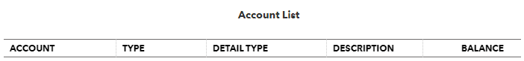
Customer/Donor Contact List
Create and save the Customer Contact list:
- Start at Reports in the left navigation bar and then locate and run the Customer Contact List report, which may also be called the Donor Contact List.
- Click the Switch to classic view button.
- Click Customize and then Filter.
- Next to the Deleted option, pick All.
- Click Rows/Columns and then Change columns.
  - Optional - Remove the following unused columns:
    - Phone Numbers
    - Billing Address
    - Shipping Address
  - Required - Add at least the following columns - but you can add more if desired:
    - Company Name
    - Customer Type or Donor Type
    - Billing Street, City, State, Zip, and Country
    - Last Name, First Name
- Run the report.
- Click Save Customization.
- Give the report a name that’ll make it easy to find later, like Donor Statements – Donor Contact List.
Your report must have columns with these names:
Note that:
- “Customer” may be titled “Donor” (Non-Profit Edition)
- “Customer Type” may be titled “Donor Type” (Non-Profit Edition)
- “Billing State” may be titled “Billing Province” (Canada)
- “Billing ZIP” may be titled “Billing Postal Code” (Canada)

Transaction Detail by Account
Create and save a Transaction Detail report:
- Start at Reports in the left navigation bar and then locate and run the Transaction Detail by Account report.
- Click the Switch to classic view button.
- Click Customize
  - Under Accounting Method, Select Cash – very important if you use invoices!
- Click Filter
  - Set the Transaction Type filter: Pick Invoice (or Pledge in non-profit), Payment, Deposit, Sales Receipt, and Credit Memo.
  - Optionally, you may also select Journal Entry & Refund transaction types.
Notes:
    - If you don’t use AR Invoices and Payments for donations then you can omit those transaction types – which will result in a smaller report, which will process faster within the Donor Statements tool
    - Similarly, if you never record donation income directly on deposits they can be omitted.
- Click Rows/Columns
  - Under Group by pick None
  - Click Change columns.
    - Optional - Remove the following unused columns:
      - Adj, Name, Split, Amount, Balance
    - Required - Add at least the following required columns:
      - Customer (or Donor)
      - Product/Service
      - Account
      - Payment Method
      - Open Balance
      - Debit
      - Credit
    - Optional – Add
      - Qty, Rate
      - Any other columns you want to see on your statements
- Run the report and then click Save customization.
- Give the report a name that’ll make it easy to find later, like Donor Statements – Transaction Details.
Your report must have columns with these names:
Where:
- “Num” may be titled “#” in Canada
- “Customer” may be titled “Donor” when using the Non-Profit Edition
Customer/Donor Balance Summary - Optional
Use this optional report if you want to notify your donors of their pledge balance – their name balance – which is essentially their unpaid invoices in QuickBooks.
Including this report will make the field [Customer Account Balance] available as a mail merge value for your statements.
Create and save a Customer Balance Summary report:
- Start at Reports in the left navigation bar and run the Customer Balance Summary report.
- Click the Switch to classic view button – if available (wasn’t available as of October 2023)
- This report doesn’t need any customization.
- Click Save customization.
- Give the report a name that’ll make it easy to find later, like Donor Statements – Customer Balance Summary.
Sales by Customer Detail - Optional
Use this optional report if you record donations on Sales Receipts and you want toinclude the Reference no. entered on Sales Receipts on your statements.
When including this report, the Reference no. will be available in the Payment Number field on donation tables, along with the payment numbers from Payments applied to invoices.
Create and save a Sales by Customer detail report:
- Start at Reports in the left navigation bar and run the Sales by Customer Detail report.
- Click the Switch to classic view button.
- Click Customize
- Click Filter
  - Set the Transaction Type filter to Sales Receipt
- Click Rows/Columns
  - Under Group by pick None
  - Click Change columns.
    - Optional - Remove the following unused columns:
      - Product/Service, Memo/Description, Qty, Sales Price, Balance
    - Required - Add at least the following required columns:
      - Customer (or Donor)
      - Ref #
- Run the report and then click Save customization.
- Give the report a name that’ll make it easy to find later, like Donor Statements – Sales by Customer Detail.
Your report must have columns with these names:
Where:
- “Customer” may be titled “Donor” when using the Non-Profit Edition
Deposit Detail - Optional
Use this optional report if you record donations directly on deposit transactions and you want to include the Reference no. entered on deposits on your statements.
When including this report, the Reference no. will be available in the Payment Number field on donation tables, along with the payment numbers from Payments applied to invoices.
Create and save a Deposit Detail report:
- Start at Reports in the left navigation bar and run the Deposit Detail report.
- Click the Switch to classic view button.
- Click Customize
- Click Filter
  - Set the Transaction Type filter to Deposit
- Click Rows/Columns
  - Under Group by pick None
  - Click Change columns.
    - Optional - Remove the following unused columns:
      - Memo/Description, Clr, Vendor
- Run the report and then click Save customization.
- Give the report a name that’ll make it easy to find later, like Donor Statements – Deposit Detail.
Your report must have columns with these names:
Where:
- “Num” may be titled “#” in Canada
- “Customer” may be titled “Donor” when using the Non-Profit Edition

Run & Export Saved Reports
After saving your reports as described above, then each time you want to create statements, you only need to run the reports from your saved Custom reports list.
To run your saved reports, start at Reports and select the Custom reports tab.
The Account List, Customer Contact List, and Customer Balance reports can be run and then sent to Excel without modification.
Run each report in sequence and send it to Excel:
- After the report runs, click the Export icon at the top of the report (next to the Printer icon) and then choose Export to Excel.
- Note and/or change the folder for the report and then save it.
Report Location: We recommend creating a folder for your reports (and just the reports) in your Documents folder. Perhaps name it Donor Reports or similar.
The Transaction Detail report
You’ll usually create just one Transaction Detail report for the entire statement period. However, you can optionally create up to three reports for the statement period if needed. This is useful if you have too much data in the statement period for QuickBooks to handle on one report.
If you create more than one transaction report, be sure that the date ranges do not overlap!
Note that you may want to run the report for a wider date range – compared to the detail you want to appear on your statements. The typical reason to do this is so that you can include the YTD total donations in the letter part of the statement while showing only recent donation details on the statements. See the Custom Text section for details.
- Confirm and/or change the date range as needed.
- Export the report(s) to Excel as you did the other reports.
- If creating more than one Transaction Detail report be sure to give each report a different name as you save it. For example, add 1,2, and 3. To the end of the report names.
Sales by Customer Detail report
To be sure you include all of the Sales Receipts which may appear on your statements, set the date range to be the same as the Transaction Detail report date range.
- Confirm and/or change the date range as needed.
- Export the report(s) to Excel as you did the other reports.
Deposit Detail report
To be sure you include all of the Deposits which may appear on your statements, set the date range to be the same as the Transaction Detail report date range.
- Confirm and/or change the date range as needed.
- Export the report(s) to Excel as you did the other reports.

Creating Statements – Selecting Report Files
To start the process to create statements, choose “Create giving statements” from the Ribbon or menu.
A window will appear where you can select your saved report files. Select them and then click Import Data to continue to the next step.
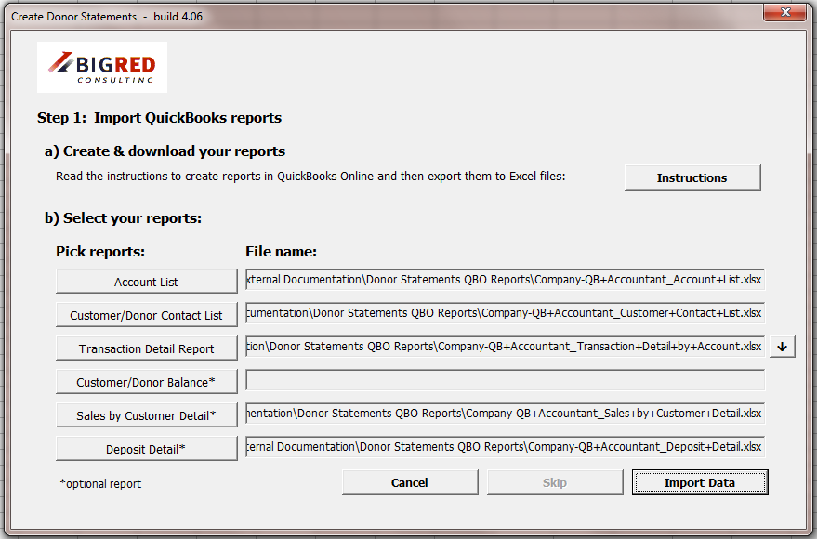
Notes
- If you need to import more than one Transaction Detail report - usually because your QuickBooks file has too much data for one report - then click the little down arrow to see additional fields.
- Your report files are saved by name, which can be useful for the next time you create statements. Later, if you save updated reports from QuickBooks using the same file names, the default reports when you start creating statements will be correct next time you run statements.
- It you start to create statements when a statement workbook is the active workbook, the Skip button will be enabled/available, and you can then click Skip to use the data already imported into the workbook to create statements again (and again and again), potentially with different settings – as you refine your settings and options.

Customizing your statements
After your reports are imported, you will be presented with another window that contains the filters and other options you can select from in order to customize your statements. There are quite a few settings that have been added to meet various needs. In many cases you either won’t need them for your needs or the default settings will work.
Settings can be separated into two types: Filters and appearance settings.
- Filters work together to select from your data only the reportable donations.
- Appearance settings let you set the text to include on your statements, the fonts to use, a logo and signature, columns to include on your detail tables a well as other settings.
Each tab of the Create Donor Statements window is covered below…

Account Filter
Select the accounts that you use for donations. This filter can help you include donations and also exclude transactions that shouldn’t be reported, that use non-donation accounts, For example sales of goods or services.
Note the data used in these screenshots is from the QuickBooks Online sample file, which is not a non-profit file and so the accounts don’t look typical for a non-profit.
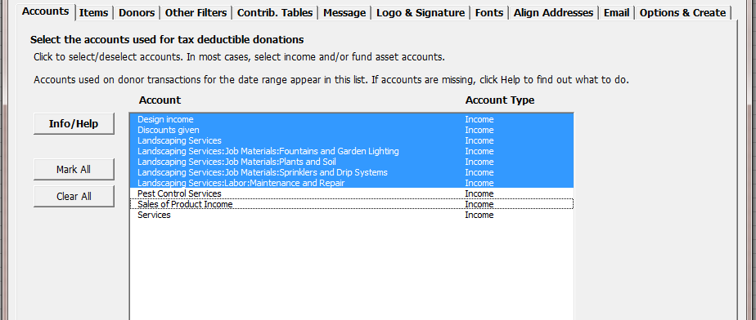

Item Filter
Optionally, you may also filter by Item.
Filters are cumulative and work together to select (and to exclude) data. So, as with the Other Filters, if you set the Items filter it further excludes data.
This means you can accidently exclude all of your data by selecting contrary filters. For example, if you pick one donation account to include and then pick only items that don’t use that account, then all of your data will be excluded.
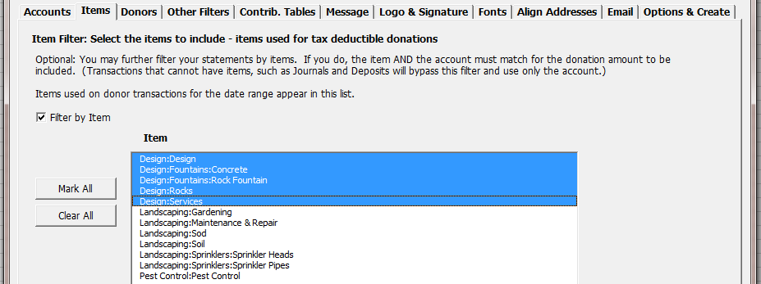

Donor Filter
Choose All donors for the period or choose the Manually select donors option. You can manually select donors one at a time and also “auto-select” them based on the Customer Type and email address, which can be helpful when emailing statements - you can run a batch of statements for customer without an email (to print) and then another batch with email address (to email).
Use the Name detail level option to choose between creating a statement for every sub-donor or one statement per donor with sub-donors, combining all the sub-donor details on one statement.
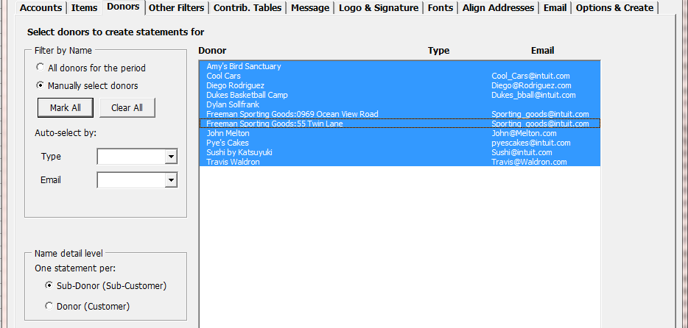

Other Filters
Set various other filters, including limiting the date range of the donations (compared to the reports sent from QuickBooks), the total donation amount, the class, filter for donors with or without pledges and other filters.
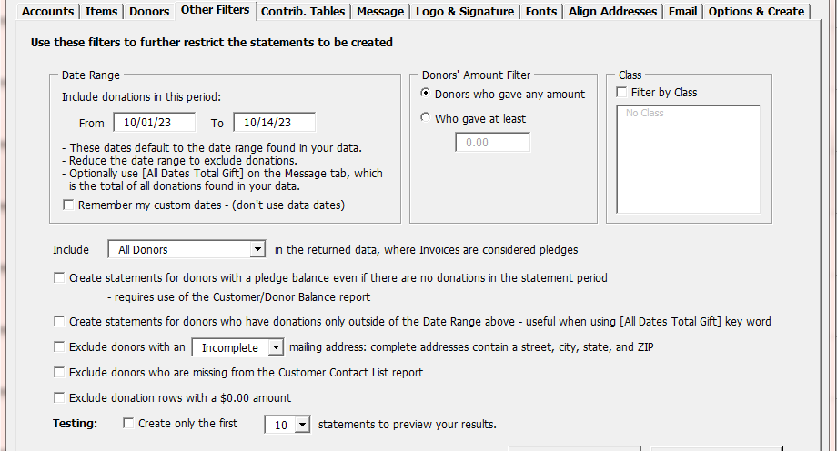
Date Range
The default date range is that of the transation data from your Tranaction Detail report. In most cases, you’ll probably want to leave the defaults alone.
However, you can reduce the date range if desired to show less detail on your statements. You might, for example, include only the prior month’s detail while including the YTD detail on your QuickBooks Transaction report.
In such as case, you can use the [All Dates Total Gift] auto-replace key word in the Paragraph fields on the Message tab, which will then resolve to the donor’s total gifts, now just those within the date range.

Contribution Tables
There are three options for contribution/donation tables: A summary table, a detail table, and no table at all.
Summary Table
The Summary table offers two options, to combine donations on the same date and for the date format. It creates a table of donations, in a grid that will look something like this:
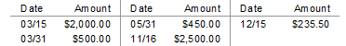
Detail Table
The most commonly used option is a detail table. It offers many options including the columns of data to show, an option to subtotal the data by most any field, to add a total to the table, and to repeat the table titles when there is enough detail to cause the table to use more than one page.
You can show any of the available columns from your QuickBooks reports that are included on the Data worksheet created when the Donor Statements processes your QuickBooks reports. The add-in defaults to a set of columns the first time you use it, and you can change them as desired.
When you subtotal, the donation data is automatically sorted and grouped by the subtotal field and amount columns are subtotaled.
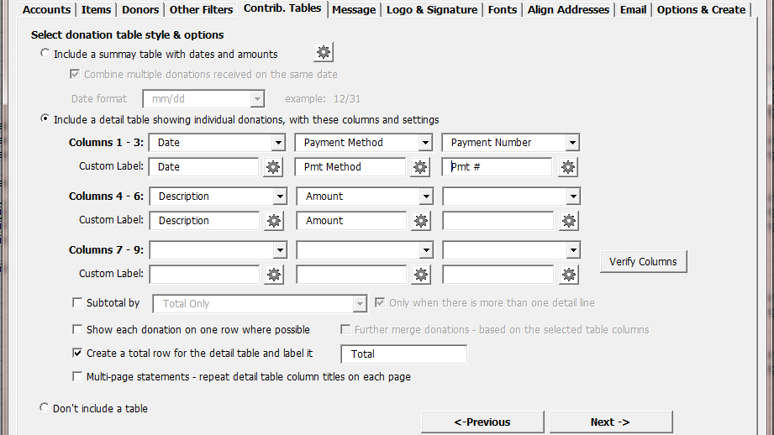

Message Text
Include custom text on your statements, which can include auto-replace key words that work like mail merge fields, customizing the statement text for each donor. They’re specified in these fields using [brackets], like the [Salutation] and [Total Gift] fields below. Details for this feature are covered in Custom Text messages section.
The footer text can be included within Excel’s footer (recommended) on the excel worksheet just after the closing paragraph.
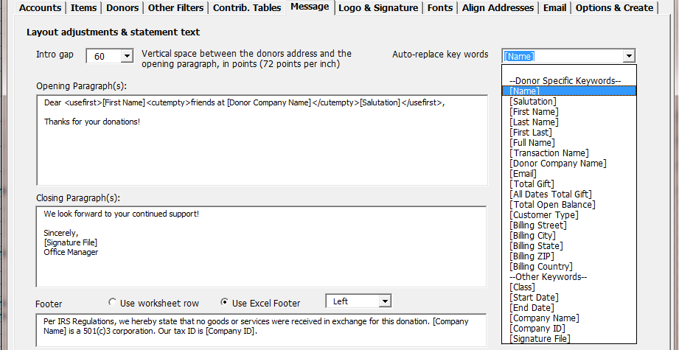

Logo and Signature Options
Specify logo and signature image files to be included on your statements.
The logo can be positioned at the top of each statement on the left, center, or right. The signature will appear as part of the closing paragraph field (or fields if it appears in the middle of that field’s text as seen above.)
Use the Auto-fit options to shrink the images, where appropriate, to fit well on the statements.
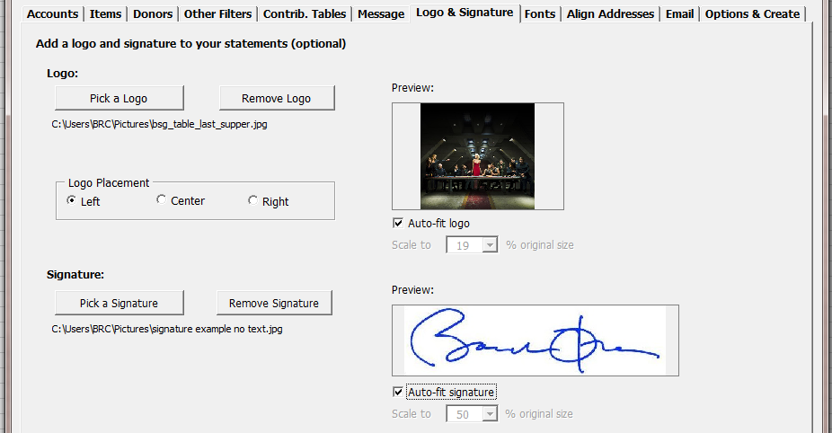

Font Selection
Set the font and font size used for various sections of your statements.
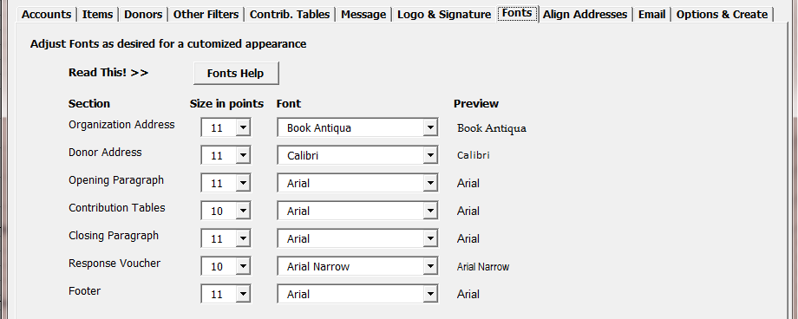

Address Alignment - for windowed envelopes
Align the company and donor address fields so they’ll fit properly in windows #10 envelopes.
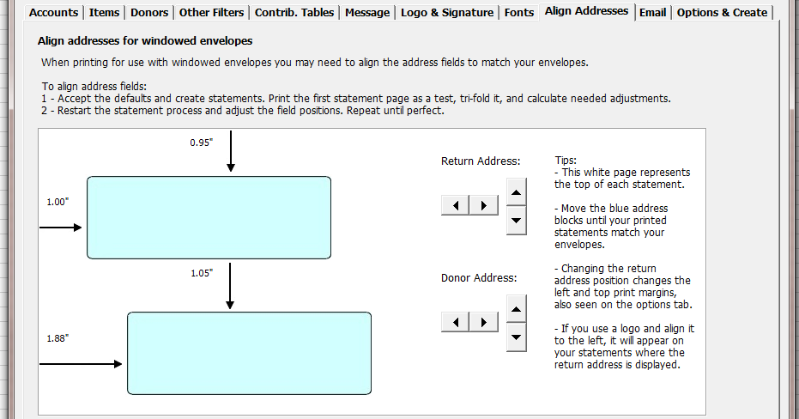

Delivery – Print or Email
Use this tab to configure the Donor Statements to send your statements directly via email. Requires the BRC Excel Batch-Email Manger, purchased separately from our site. For details, see the section Emailing Statements.
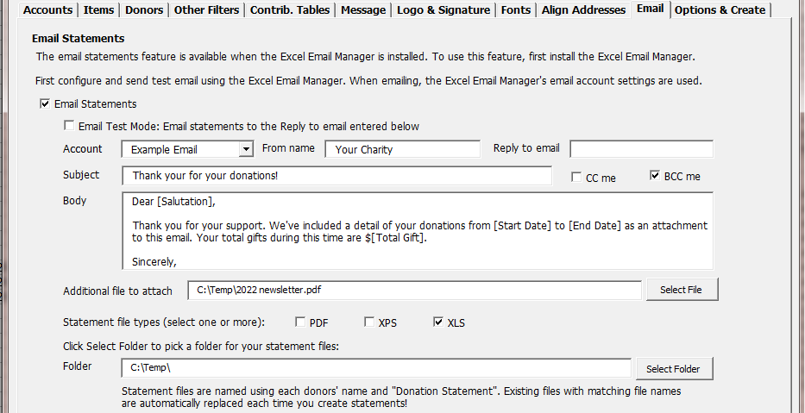

Statement Options
Set various other options for your statements, including statement sorting, numbering statements, including the statement date, setting the margins, and other options. And then (finally!) click Create Statements.
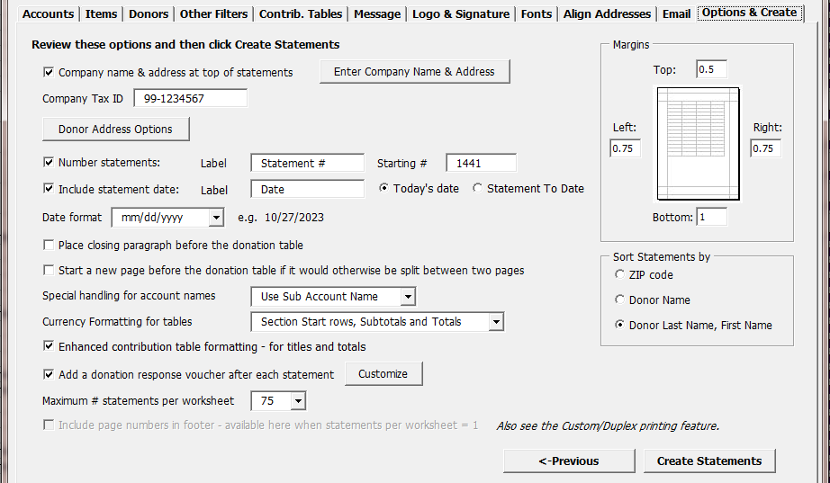

Enter Company Name & Address
Click this button to enter your return address as you’d like it to appear on statements.
Donor Address Options
These options control how the salution for the address and the [Salutaion] auto-replace key words will appear on your statements.
Because QuickBooks online doesn’t have an address block you can control, but instead assembles the address the way it wants to each time you create a sales receipt or invoice, the Donor Statements doesn’t have an address block to pull directly from QuickBooks.
We’ve included these settings so that you can control what salutations print on your statements.
As the window notes, you can pick first, second, and third choices for both the first and optional second salutations. This way, if your donor records vary - if some are missing values in fields like the FML fields or the company name field and others are not - the Donor Satements will pick the best match for each donor, per your settings.
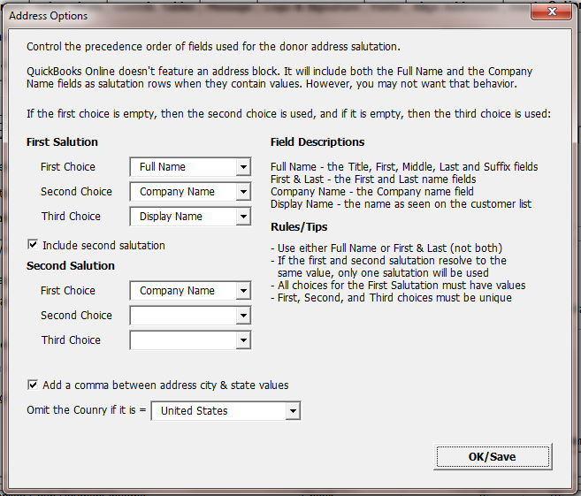
Donation Response Voucher
Add a “tear off” voucher to the end of each statement, either at the bottom of the page or on its own page. It can include the donor’s name and address and most any text you wish, as well as special formatting options.
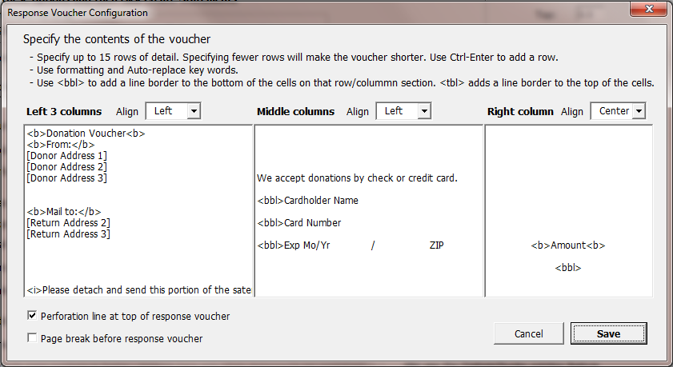
The configuration can take bit of work to get the results you want. The default settings you see above produce a response voucher that will look like this when printed:
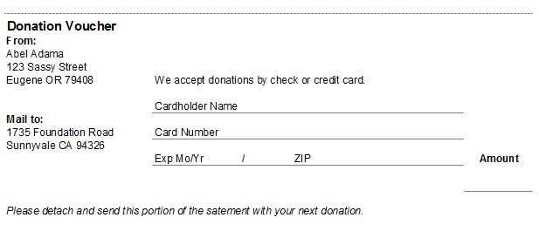

Custom Text Features
Use these custom text features in the Opening Paragraph(s), Closing Paragraph(s), the Donation Voucher fields, and the Footer. Also, when emailing statements, the email Body field is supported.
In these fields, you can specify custom text, custom text formatting, “auto-replace” fields, and conditional text based on auto-replace fields.
Note that after creating statements and reviewing the results, you can re-create statements using the data already pulled from QuickBooks, over and over again, which can help you refine the text on your statements using the features described in the following sections.
To create statements with data already pulled from QuickBooks, make a statement workbook the active workbook and then start the process to create statements. Use the Skip button to bypass pulling data from QuickBooks.

Text Formatting – bold, italic, and underlined
Format text within these fields using html-like code pairs that surround the target text. Use them to bold, underline, and italicize portions of your text messages. Use these keywords:
- To bold text, use <b> and </b>
- To underline, use <u> and </u>
- To italicize, use <i> and </i>
For example, if you specify a sentence like this:
I like to include <b>bolded</b>, <u>underlined</u>, and <i>italicized</i> text from time to time on my statements!
It will appear on your statements like this:
I like to include bolded, underlined, and italicized text from time to time on my statements!
You can use these formatting codes together.
For example, if you specify
<u><i><b>We want it all!</b></i></u>
You’ll get
We want it all!
If you use <b>, <u>, or <i> and don’t include the closing </b>, </u>, or </i>, then the rest of the text will be formatted accordingly.
For donation vouchers you can also use the codes <bbl> and <tbl>, which are used to place a line border at the bottom or top of worksheet cells, to help make the voucher look more like a form. Use <bbl> for a bottom border line and <tbl> for a top border.

Auto-Replace Key Words
Auto-replace fields use keywords that are surrounded with square brackets. When you use them, the field is replaced with the value appropriate for each donor based on your QuickBooks data. For example, if you enter [Name] as part of your text field, [Name] will be replaced on each statement with that donor’s actual name.
There are two types of keywords.
First, most every data field/column from the QuickBooks data can be used as a key word. The best columns to use are those related to the donor and not the donations. This is because the value from the first row of data found for each donor becomes the replacement value. For example, in the data the donor’s [Name] will always be the same, but fields like [Account] or [Class] can vary per donation.
Second, there is a list of special calculated fields that can be used.
Use any of these special keywords in your text. See the complete list of special key words in the Auto-replace key words drop down list on the Message tab.
Name | Meaning
[Salutation] | This special field derived from your data. It uses your settings from the Donor Address Options feature to determine the best Salutation per donor.
[Salutation 2] | This is a special field derived from your data. It also uses your settings from the Donor Address Options window to determine the value for each donor.
[First Name] | The donor’s first name as entered from the customer record.
[Last Name] | The donor’s last name as entered from the customer record.
[First Last] | The Donor’s First and Last name fields combined.
[Name] | The Transaction Name
[Donor Company Name] | The donor’s Company name as entered from the customer record.
[Start Date] | The From date as entered in the create statements window.
[End Date] | The To date as entered in the create statements window.
[Total Gift] | The total amount of the donations for the period of the Start Date and End Date.
[All Dates Total Gift] | The total amount of the donations for all data found on the imported Transaction Report – on the Data worksheet.
[Total Open Balance] | The customer/donor balance, available if you use the optional customer balance summary report.
[Company Name] | The (your) charity’s legal name.
[Company ID] | Your charity’s Federal Tax ID.

Conditional Text
The conditional text feature works with the auto-replace fields. It allows you to make parts of your text message fields display on statements if all of the auto-replace fields within the conditional text sections return non-empty values, or non-zero values for amount fields.
To specify conditional text, surround the target text with the tags <cutempty> and </cutempty>.
Example:
<cutempty>Thanks for your pledge, which has a balance of [Total Open Balance].</cutempty>
If the Total Open Balance is 0.00, then the entire section of text is omitted.
If the conditional text stands alone as its own paragraph, then for best formatting you may want to put the tags on the preceding or following rows. This will avoid a large empty space on the resulting statement.
Four examples:
- This text will result in three empty rows between paragraphs if the open balance is 0.00:
Thank you so much for your total donation of [Total Gift].

<cutempty>Also, thank you for your pledge, which has a balance of [Total Open Balance].</cutempty>

We look forward to your continued patronage.
- This text will result in one empty row between paragraphs:
Thank you so much for your total donation of [Total Gift].
<cutempty>
Also, thank you for your pledge, which has a balance of [Total Open Balance].
</cutempty>
We look forward to your continued patronage.
- This text will result in one paragraph, if the open balance is 0.00, and three paragraphs if it is not:
Thank you so much for your total donation of [Total Gift]. <cutempty>
Also, thank you for your pledge, which has a balance of [Total Open Balance].
</cutempty>We look forward to your continued patronage.
- This text will result in one paragraph, either if the open balance is 0.00 or if it is not:
Thank you so much for your total donation of [Total Gift]. <cutempty>Also, thank you for your pledge, which has a balance of [Total Open Balance]. </cutempty>We look forward to your continued patronage.
Rules
-If there is no [keyword] between the conditional tags, the text will always remain.
-If there are two or more key words between the conditional tags, then if any of them are blank, all of the text is removed.
- If an opening tag is not followed by a closing tag, and there are no closing tags then there is no effect on the text. If there are multiple opening tags followed by a closing tag, the first opening and first closing tag are paired and all the text between is considered together and omitted together.

Use First
The Use First feature allows you to list two or more mail merge fields in a row and include only the first non-empty (or non-zero) value on your statements.
Using the Use First feature you can control how your statement salutation (or other text) appears.
To specify a sequence of Use First key words, surround the target text with the tags <usefirst> and </usefirst>.
Example:
Dear <usefirst>[First] [Donor Company] [Contact] [Salutation]</usefirst>,
Using this example, if the donor record has a first name, it will be used. If not, then if the donor has a Company Name it will be used, and if not then if they have a Contact name it will be used. And then finally if all of those fields are blank the special salutation field will be used.
Note that the resulting text is ‘managed’:
- Spaces are inserted before and after key word results.
- Double spaces are removed.
- A single space character - if used - after <usefirst> or before </usefirst> is retained.
This means that the following text in your message fields will have the same results on your statements:
<usefirst>[First][Donor Company][Contact][Salutation]</usefirst>
<usefirst>[First] [Donor Company] [Contact] [Salutation]</usefirst>
<usefirst>[First] [Donor Company] [Contact] [Salutation]</usefirst>
It also means that the following text examples will have different results, because of the spaces in the second example, just after <usefirst> and before </usefirst>.
<usefirst>[First][Donor Company][Contact][Salutation]</usefirst>
<usefirst> [First][Donor Company][Contact][Salutation] </usefirst>

Use First and Conditional Text together
You my use the <cutempty> and <usefirst> features together in the same text fields.
They can be used in different parts of the text, or you can include <cutempty> within <usefirst>!
For example, if you want to use a customer’s first name if they have one, and otherwise use the company name, but you want some extra text when using the company name, something like this will work:
Dear <usefirst>[First Name]<cutempty>friends at [Donor Company Name]</cutempty></usefirst>,
Using this example, if there is a first name then you’ll get a salutation like:
Dear John,
But if there isn’t a first name but there is a company name, then you’ll get something like:
Dear friends at Acme Construction,
Aligning statement data
The Donor Statements add-in can be used to print or email statements. When printing, it is intended to create statements which can be tri-folded and stuffed into windowed #10 envelopes, so you don’t need to manually address your donation statements or even print and affix mailing labels.
To fine-tune alignment settings, we suggest creating a trial run where you print one statement from those created. To do this, first create statements as usual. Then print just the first page and Z-fold it, and check it for alignment with your windowed envelope stock. If needed, change settings then re-create statements and try again.
Custom Alignment Settings
Note that adjustments impact statements about to be created, not any exiting statement worksheets.
Intro Gap
This is the vertical space between the donor address and the intro paragraph text. The setting is found on the Message tab.
Align Address
This tab lets you move both your company address and donor addresses left or right, and up and down to match your windows envelopes.
Margins
After making the adjustments above, if your address fields don’t align, also try making adjustments to your statements using the Margins section on the Options & Create tab of the create statements interview.

Printing statements
When printing statements, you can use Excel’s standard print functionality. Or, you can use the special Custom/Duplex print feature we’ve built just for statements.
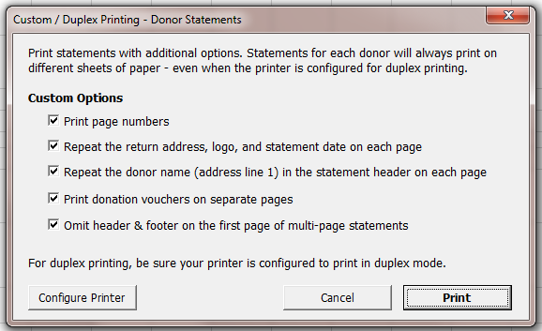
The custom printing optoins work whether or not you have set up your printer to print in duplex mode.
Print Page Numbers
When your statements worksheet contains multiple statements, each statement will start with “Page 1”.
Repeat the return address
When selected, the top of each page of a multi-page statement will iclude your company name and address, your logo, and the statement date.
Repeat the donor name
When selected, the donor’s name will appear in the top right header of each printed page. This can be useful for multi-page statements, to make sure you have the correct pages together.
Print donation vouchers on separate pages
When selected, and when printing in duplex mode the voucher will always be printed on its own piece of paper, and never on the back side of the statement.
Omit header & footer on the first page
When selected, the header and footer are omited of the first page of multi-page statements. The header and footer will still print on the first page of shorter statements that fit on single-page.

Emailing Statements
Donor statements can be emailed instead of printed, saving effort and postage. This is possible when using the BRC Excel Batch-Email Manager, which can be purchased on our site.
There are two ways to email statements:
- Recommended: Email fully-formed statements as attachments directly as they are created by the Donor Statements. When viewed by the customer they’ll look just like printed statements.
- Create a mail merge table and use it to email statements using some other method.

Email Statements using the Excel Batch-Email Manager
Use this option to email statements as they’re created from within the Donor Statements.
Statements are created and sent to each donor’s email address as attachments, using email addresses from their customer records in QuickBooks. The email addresses must be valid internet email addresses.
Tips:
- To send a donor’s statement to more than one email address, enter the addresses in the QuickBooks email address field separated with commas, like “john@test.com, jane@test.com”.
- When an email is sent to a donor, it is tracked on the “Email Log” worksheet. If you email statements again from the same Donor Statements workbook, donors listed on the Email Log worksheet will not be sent a statement.
- To email a statement to a donor that has already been sent one, remove their name from the Email Log worksheet.
- Use the “auto-select” feature to quickly select donors with email addresses, or – when printing statements – those that don’t have email addresses.
- As statements are being created and emailed, you can see the progress in Excel’s status bar.
- If there is an error when emailing a statement, you’ll receive an error message with the option to stop emailing.
- You can create and email statements when the Donor Statements and Email Manager are in trial mode – though you can’t pick who will be sent a statement. We recommend sending statements using the email “Test mode” option during the trial, which allows you to send the statements to yourself for review.
Basic set-up
1. Install and configure the BRC Excel Batch-Email Manager. Test your mail account using the Email Manager’s test feature to be sure it’s working with your mail server. Once working, it’s ready to be used with the Donor Statements add-in.
2. Start the process to create statements. When licensed (not in trial mode), you can manually select donors, including an option to auto-select those with or without email addresses.
3. Select the option to email statements on the Delivery tab, where you can enter the subject and the body of the email, pick the email account to use, and choose other options.

Email Settings - Field by Field
These settings are found on the Email tab of the Create Statements window.
Email Test Mode: In test mode, up to three statements are sent and you’re able to specify the address the statements are sent to.
Account: The Email account to use. The email accounts set up in the Excel Batch-Email Manager will appear in the list. Choose any account set up in the Excel Batch-Email Manager.
From name: The name your donors will see.
Reply to: The email address for any replies from your donors (not available in email test mode).
Test email: The email address test emails will be sent to (only appears when in email test mode).
Subject: The subject that the donor will see.
Body: The body of the email.
CC me: Check this box and you’ll receive a copy of each email sent.
BCC me: Check this box and you’ll receive a blind copy of each email sent.
Additional file to attach: Select an additional file to attach to all your emails, such as a newsletter.
File settings
When emailing, you may select one or more of these attachment file types. A statement will be created and saved in each of the selected file types and they will then be sent as attachment(s):
PDF: Creates a standard PDF file attachment.
XPS: Creates a standard XPS file attachment. – The XPS format is used by the Microsoft XPS Document Writer, and all or nearly all Windows machines come with this utility preinstalled, so most all Windows users should be able to open a file in this file format.
XLS: Creates an Excel workbook attachment.
Folder: The folder used to save statement attachments before they’re emailed.

Mail Merge Table
The mail merge table is a completely different way to use the Donor Statements tool. This option is suitable for creating mailing labels or statements for your customers in another application such as Microsoft Word. The resulting mail merge table may also be useful as a data source for other needs.

Creating a mail merge summary table
To start the process to create a mail merge table, pick the option “Create mail merge table” from the custom Ribbon or menu.
The resulting interview to create your mail merge table is similar to the Create Statements wizard, asking only applicable questions. Some settings are shared with the Create Statements wizard.
The mail merge feature creates a new workbook containing a worksheet of data where each donor record occupies one row on the worksheet. It contains information such as the name and address, total giving for the matching accounts, and both HTML and text fields containing tables of donation data similar to those included in Excel-based statements.
Once this worksheet is created and saved, you can use it as a data source in MS Word to create mail merge letters or to email the data. See Word’s documentation for steps to use its mail merge features.
When you install the Donor Statements tool, an example Word doc that matches the mail merge data is also installed. It is named “Donations Mail Merge Template”. Using MS Word, you can use it as a starting point for your mail merge process.

Housekeeping - Installing & Purchasing the Donor Statements
This is an overview of various utility operations relating to using the Donor Statements Add-in.

Install the add-in
After running the installer, the installation is normally complete and there is nothing more to do.

Load the App as an Excel add-in
If for some reason the Donor Statements is not currently loaded, you may load it from within Excel manually. Once loaded, each time Excel starts the add-in will be available until you unload it. To load the add-in, first start Excel & make sure a workbook is open (one usually opens when you start Excel.)
Excel 2010 – 2021:
1. Select File, then Options from Excel's menu.
2. In the Options dialog, select Add-ins.
3. At the bottom of the add-ins pane, select Excel Add-ins and press Go.
4. When the Add-ins dialog opens, click Browse and navigate to the folder where you installed the add-in.
5. Select the *.xla file and then OK to close the dialogs.
Excel 2007:
1. Click the Microsoft Office Button and then click Excel Options.
2. Click Add-Ins and then in the Manage box select Excel Add-ins. Click Go.
3. In the Add-Ins available box, click Browse... and navigate to the folder where you installed this add-in.
4. Select the *.xla file & then OK to close the dialogs.
Excel 2003:
1. In Excel choose Tools | Add-ins from Excel's menu.
2. Click Browse and then navigate to the folder to which you installed the add-in.
3. Select the *.xla file & Press OK to close the dialogs.
At this point, you should see this add-in listed in the Add-In dialog, with a checkmark next to it. Press OK to close the dialog, which will load the Add-In. Once it loads, you’ll see a new Ribbon tab or menu item in the Add-ins tab, or for older versions of Excel a menu to the right of Excel’s help menu.

Trial Period
The add-in will be in “trial” mode until you enter your primary product key. In trial mode, most features are available, but there are limitations to the number of statements that can be created.

Purchase & Enter your primary product key
To purchase the add-in, select About & Purchase from the custom ribbon in Excel. Click the Purchase button and you’ll be taken to our website to make your purchase. When you complete the purchase, we’ll send an email with your receipt and product key.
To enter your key, choose About & Purchase from the Ribbon and then add the key.

Moving to a new computer
To move to a new computer, the basic steps are to install the Donor Statements there and to copy your settings, including custom templates.
The best-practice steps are:
On the current computer
- Click Export settings on the Donor Statements’ Ribbon tab. Create the file, noting the location. The default file name will be NONPROFNOTICEQBO_Settings.dat.
- Copy the *.dat file to the new computer.
On the new computer
- Install the Donor Statements. You can get the installer again from our site from this page: Get the Newest Product Build
- Launch Excel and click Import Settings on the Donor Statements’ Ribbon tab and then locate and import the NONPROFNOTICEQBO_Settings.dat file.

FAQs
No statements are created
Make sure your ‘filters’ don’t exclude all of your donation data.
For example, make sure you select all the accounts used on donations, all the donors, and have not set a ‘floor’ amount to exclude small donations. Also, make sure the date range for the statements includes the dates of the data actually included on your QuickBooks reports.
Only three statements are created
Check to make sure the “Sample Mode” option on the Filters slide of the wizard is not selected. If it is, de-select it and try again.
Can I create statements again without connecting to QuickBooks?
Yes, with a workbook created by the add-in open, you can start the process to create statements and then use the “Skip” button to proceed.
I upgraded Excel and the add-in is gone
Each version of Excel has its own list of loaded add-ins. MS calls this a feature. So, when you upgrade excel, none of your custom add-ins will be loaded. The easiest fix to this is to rerun the installer. If you don’t have it, you can download it again from www.bigredconsulting.com

Troubleshooting

Appearance of Statements
Fonts appear too small when printing
Fonts may appear smaller than usual when printing if the statement is so wide that Excel must scale it down to fit on the printed page (fit to one page wide.) To change this and reduce the statement width, try these tactics:
- Make the table font smaller than the rest of the statement. Do this in the wizard as you create statements.
- Make the text font for the paragraphs of text larger, while leaving the table font as-is.
- Remove one or more columns from the data table in order to make it narrower.
- For wide columns, when defining the columns in the interview, click the little gear button and force the column to be narrower by selecting a specific value from the list.

Example Statement
Many options are available to modify statements. This example includes commonly used columns:


