

Excel to OFX Converter
Introduction
Thank you for your interest in this product, by Big Red Consulting.

We’ve written this document to ensure you have a smooth start when using the tool, and to address frequently asked questions. This document contains several sections, listed below.

Please note:
Quicken and QuickBooks are registered trademarks of Intuit, Inc.
MS Excel is a registered trademark of Microsoft, Inc.
The Excel to OFX Converter and this document are copyrighted by Big Red Consulting.

Excel to OFX Converter 1
Overview 2
Create an OFX bank/credit card worksheet 3
Layout Guidelines 3
Create an OFX investment worksheet 4
Layout Guidelines 4
Supported Security Actions 5
Supported Security Types 5
Creating an OFX/QFX/QBO file 6
Importing your QBO file into QuickBooks 7
Importing your QFX file into Quicken 8
Importing your QFX Investment file into Quicken: Special Additional Instructions 9
Options & Settings 10
Layout 10
Columns 11
Types & Amounts 12
Essential Activities 13
Installing 13
Loading in Excel 13
Trial Period 14
Moving to another computer 14
Frequently Asked Questions 14

Overview
The Excel to OFX Converter is an Excel “Add-In”. This Add-in enables you to use Excel to create OFX files for import into other applications. The Excel to OFX Converter will create standard OFX files as well as QFX files for Quicken and QBO files for QuickBooks.
This Add-In creates a special menu that provides access to its features within Excel. Use this menu to access its features.
Once installed, access the product’s features from its ribbon tab in Excel. It will look something like this:
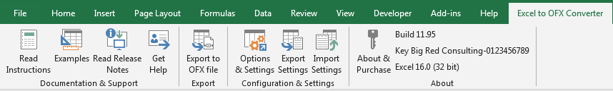
Read Instructions
Open this document!
Examples
Open an example workbook with examples for banking/credit card transactions and for investment transactions.
Read Relase Notes
Open the product’s home page on our site and read the recent release notes. The button will change to “Get Build” when there is an update available.
Get Help
Options include creating a support request on our site.
Export to OFX file
Start the process to create an OFX file.
Options & Settings
Map custom columns and select from other options.
Export and Import Settings
Use these features to create a backup of your settings, or to move them to another computer.
About & Purchase
Enter your product keys and review your license status.

Create an OFX bank/credit card worksheet
Use this add-in to create your own OFX files from spreadsheets containing banking and credit card transactions.
In this document, references to “format” refer to the layout of your data on an Excel worksheet, not the Excel cell formats applied to the data (bold, currency, and so on.) You can use any font, underlining, cell formatting, or other Excel features to help you better analyze your data.

Layout Guidelines
- The first row of the active spreadsheet should contain titles for your transactions, like the example just below. Standard recognized columns titles are: Date, Doc Num, Name, Memo, and Amount.
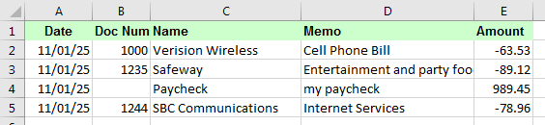
The labels in row 1 are the default column headers. When you export, your column titles will either turn green or yellow. Green means the column is recognized and yellow means it is not - and in that case it will not be included in your OFX file.
- The column titles must match what the product is looking for or they will be ignored. Columns can be in any order.
- You may use different column titles or you may omit column titles!
  - To select custom column titles, click the Options & Settings button on the custom ribbon tab, or pick Options & Settings from the custom menu (older Excel).
  - If you don’t have column titles, indicate that on the layout tab. Then select the Columns tab and pick from your columns for each data field that uses a non-standard column name – or no name.
- Transactions are laid out in rows & columns, spreadsheet-style. Each transaction occupies one spreadsheet row.
- Payments you make (like checks) should have a negative amount and money you receive (deposits for banking) have positive amounts.
  - If your amounts are the opposite, you can select the option Reverse amount sign as you export to an OFX file.
- Only the Amount column is required. Everything else is optional.
  - If you don’t specify a date column, today’s date will be used.

Create an OFX investment worksheet
Use this add-in to can create your own OFX files from spreadsheets containing investment transactions.

Layout Guidelines
- The first row of the active spreadsheet should contain titles for your data, such as “Date” and “Amount”.
  - Standard recognized columns titles are: Date, Action, Security, Symbol, Security Type, Memo, Price, Quantity, Commission, and Amount.
- The column titles must match what the product is looking for or they will be ignored. Columns can be in any order.
- You may use different column titles or you may omit column titles!
  - To select custom column titles, click the Options & Settings button on the custom ribbon tab, or pick Options & Settings from the custom menu (older Excel).
  - If you don’t have column titles, indicate that on the layout tab. Then select the Columns tab and pick from your columns for each data field that uses a non-standard column name – or no name.
- Transactions are laid out in rows & columns, spreadsheet-style. Each transaction occupies one spreadsheet row.
- For investment transactions, the required columns vary by Action (Buy, Sell, and so on.) This example shows all the supported Actions:
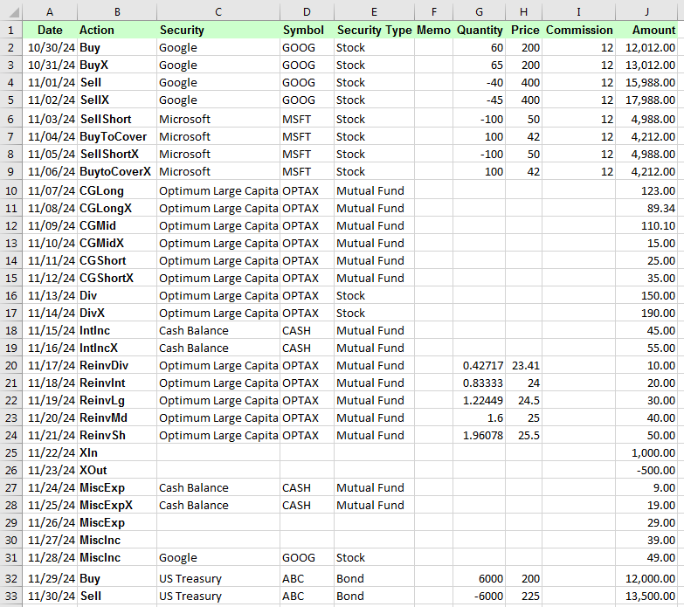
The image shows most supported Action codes. The labels in row 1 are the default column headers. When you export, your column titles will either turn green or yellow. Green means the column is recognized and yellow means it is not - and in that case it will not be included in your OFX file.
.

Supported Security Actions
Action | Comment | Required Data
Buy | A security Buy | Date, Action, Security, Price, Quantity, Amount
BuyX | A security Buy and transfer of cash from another account | Date, Action, Security, Price, Quantity, Amount
Sell | A security Sell | Date, Action, Security, Price, Quantity, Amount
SellX | A security Sell and transfer of proceeds from another account | Date, Action, Security, Price, Quantity, Amount
SellShort | Sell a security short (one that you have borrowed) hoping the price will decline. | Date, Action, Security, Price, Quantity, Amount
SellShortX | Like SellShort, but includes a transfer of the funds to another account. | Date, Action, Security, Price, Quantity, Amount
BuyToCover | A buy to cover a previous Short Sell transaction (hopefully when the price has dropped.) | Date, Action, Security, Price, Quantity, Amount
BuyToCoverX | Like a BuyToCover, but funds are transferred to cover the purchase. | Date, Action, Security, Price, Quantity, Amount
CGLong | Long term capital gains | Date, Action, Security, Amount
CGLongX | Long term capital gains and transfer of proceeds to another account | Date, Action, Security, Amount
CGMid | Mid-term capital gains (converted to short term on import as OFX doesn’t support this) | Date, Action, Security, Amount
CGMidX | Mid-term capital gains and transfer of proceeds to another account | Date, Action, Security, Amount
CGShort | Short Term Capital Gains | Date, Action, Security, Amount
CGShortX | Short-term capital gains and transfer of proceeds to another account | Date, Action, Security, Amount
Div | Dividend | Date, Action, Security, Amount  Optional: Price, Quantity (If present, the Div is assumed to be a ReinvDiv)
DivX | Dividend and transfer to another account | Date, Action, Security, Amount
IntInc | Interest Income | Date, Action, Security, Amount
IntIncX | Interest Income and transfer to another account | Date, Action, Security, Amount
ReinvDiv | Dividend reinvested | Date, Action, Security, Price, Quantity, Amount
ReinvInt | Interest Income Reinvested | Date, Action, Security, Price, Quantity, Amount
ReinvLg | Long term capital gains Reinvested | Date, Action, Security, Price, Quantity, Amount
ReinvMd | Mid- term capital gains Reinvested | Date, Action, Security, Price, Quantity, Amount
ReinvSh | Short-term capital gains Reinvested | Date, Action, Security, Price, Quantity, Amount
XIn | Transfer of cash into the account | Date, Amount
XOut | Transfer of cash out of the account | Date, Amount
MiscExp | Misc Expense | Date, Amount
MiscExpX | Misc Expense covered by another account | Date, Amount
MiscInc | Misc Income, optionally associated with a security. | Date, Amount
MiscIncX |  | Date, Amount

Supported Security Types
Type | Code(s) | Comments
Stock | Stock, ST | The default type if none is specified.
Mutual Fund | Mutual Fund, Fund, MF
Bond | Bond, Debt
Other | Other, Oth

Creating an OFX/QFX/QBO file
Create an OFX file ready to be imported into an application like Quicken or QuickBooks.
When exporting, you have several options as seen below.
Be sure to pick the proper currency (usually UDS) and to enter Account and Routing numbers for bank accounts or your Account number for credit card accounts:
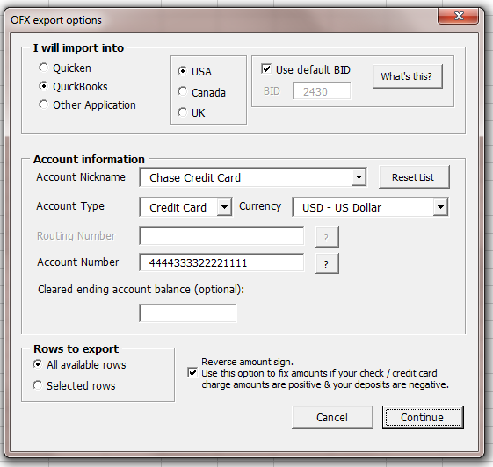
Field comments:
I will import into: Pick the appropriate application and country version.
Account Nickname: Enter or pick your account name here, and then fill in the Type, Currency, and account number fields.
Currency: This is the currency list supported by OFX. US Quicken users should always use USD, even for international accounts.
Rows to export: You may export your entire spreadsheet, or only the selected rows.
Reverse amount sign: This option reverses the sign on all the transactions in your worksheet during export (but doesn’t change the sheet.)

Importing your QBO file into QuickBooks
QuickBooks expects its OFX data in files with the QBO file extension and refers to these files as Web Connect files. If you choose QuickBooks, the tool will automatically create a file with the QBO extension, even if you specify another file type. After you’ve created a QBO file it’s time to import it into QuickBooks.
To import your QBO file, pick File | Utilities | Import | Web Connect Files…
On your first import, you can select an existing account or create a new one.
Note: If you want to import into an account that already exists, but that is not available for import, this probably means that different bank feeds account information is saved for that account. In this case, cancel the import, then edit the account from the chart of accounts and disable/remove the bank feeds information. Then try importing again. Your account should be available to select.
After import, use the QuickBooks bank feeds feature to accept the new transactions.
Notes:
- QuickBooks will incorrectly identify the Financial Institution during import of the QBO file. You may ignore this.
- QuickBooks may also go online during the import process, even though it is not downloading your file. You may have to allow this or QB will not continue.
- Once you associate the Web Connect file with a QuickBooks Account, each subsequent import with the same account number will automatically be associated with that account. To import into another account, change the account properties in the OFX Export dialog before creating the file.

Importing your QFX file into Quicken
Quicken expects its OFX data in files with the QFX file extension and refers to these files as Web Connect files. If you choose Quicken, the tool will automatically create a file with the QFX extension, even if you specify another file type. After you’ve created a QFX file it’s time to import it into Quicken.
Different versions of Quicken have slightly different menu options for importing. Look for an import option on the File menu, and then a sub-option for Web Connect files. Choose it and then browse to the location you saved your QFX file.
Quicken will ask you several questions when importing, such as whether to use an existing or new account. Note that only accounts of the correct type and not already setup for online banking will be available when selecting accounts.
Processing your data
After importing data into Quicken, one of several things may happen:
- You may be prompted that import was successful, but that there are no new transactions to review (even though transactions were imported.) Check your register for the new transactions.
- You may be prompted that there are transactions to review and your register will open, with the new banking transactions in a window at the bottom of the register.
Notes:
- Quicken will incorrectly identify the Financial Institution during import of the QFX file. You may ignore this.
- Quicken will also go online during the import process, even though it is not downloading your file.
- Once you associate the Web Connect file with a Quicken Account, each subsequent import file with the same account number (see Fig 2.) will automatically be associated with that account. To import into another account, change the account properties in the OFX Export dialog before creating the file.

Importing your QFX Investment file into Quicken: Special Additional Instructions
Quicken will ask you several questions when importing, such as whether to use an existing or new account. Note that only accounts of the correct type and not already setup for online banking will be available when selecting accounts.
Processing your data
After importing data into Quicken, one of several things may happen:
- You may be prompted that import was successful, or not.
- To view the transactions, you may need to click on another account, and then back to the investment account to refresh it, and then click the “Downloaded Transactions” tab at the bottom of the “Transactions” view of your account. Usually pressing “Accept All” will record all your transactions.
- After accepting your data, Quicken will usually display the “Adjust holdings amount” dialog and suggest that your total owned shared are 0. This happens because the tool doesn’t supply security balances at all at this time (only detailed transactions) and then Quicken assumes this means your balances are 0. Press Cancel at this dialog.
- When importing for the first time into an empty account or new account created during import, Quicken many automatically enter adjustment entries to the beginning/top of the account register (one day before your first activity) to cancel out all your holdings. To work around this, delete these “Entry” transactions, listed in bold at the top of the register. To delete them, right click on each transaction and choose delete.
Notes:
- Quicken will also go online during the import process, even though it is not downloading your file.

Options & Settings
To open the Options & Settings window, click Options & Settings from the custom Ribbon tab or menu (older Excel). The window contains several tabs, reviewed here.

Layout
Use the Layout tab for the column titles option. If your worksheet doesn’t have column titles, then you can map columns by column letter on the Columns tab:
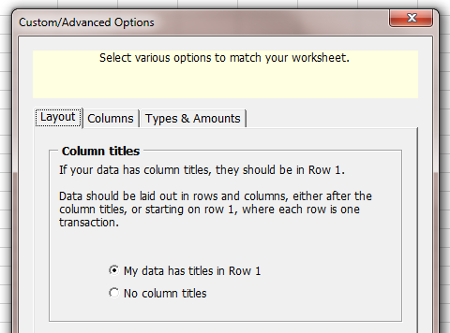

Columns
Use the Columns tab to map columns with non-standard names to the various supported fields.
If the option for no column titles is selected, you’ll see column letters in the drop lists:
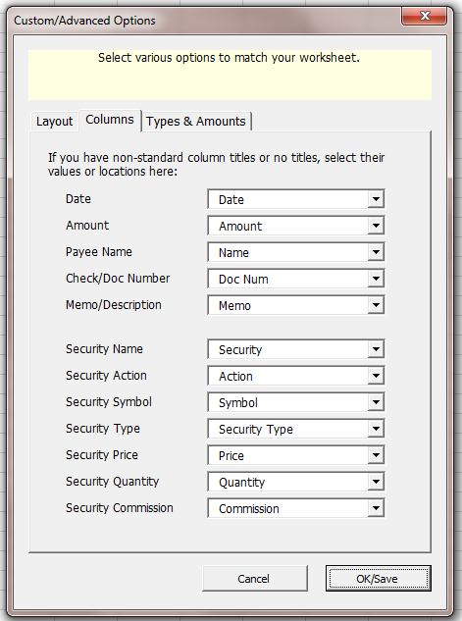

Types & Amounts
Use the Types & Amounts tab if you have a column that specifies the type of transaction on each row of your file.
For example, a banking file that indicates if the row is a check or deposit or some other type of transaction.
Select the column that contains the types and then accept the default values for increases and decreases or add your own, placing a comma between each value as seen below.
Finally, select the last two options, which control how the transactions are coded in the OFX file.
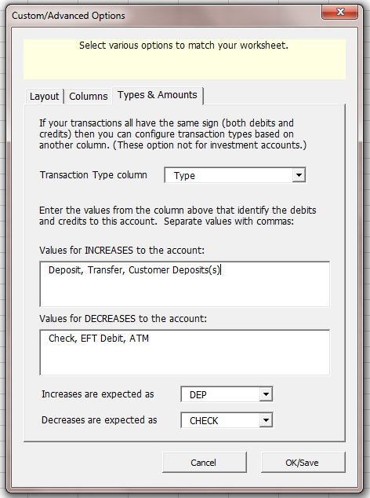

Essential Activities
This is an overview of various utility operations you may want to complete when using the tool. The later sections in this document cover the steps for using the tool.

Installing
If you downloaded the installer and ran it, installation is usually complete.

Loading in Excel
If you didn’t use the installer, or the products didn’t automatically load in Excel, you may load manually. This is a one-time process. Once loaded, each time Excel starts the tool will be available until you unload it:
To load the tool, first start Excel & make sure a workbook is open (one usually opens when you start Excel.)
Excel 2010 - 2021:
1. Select File, then Options from Excel's menu.
2. In the Options dialog, select Add-ins.
3. At the bottom of the add-ins pane, select Excel Add-ins and press Go.
4. When the Add-ins dialog opens, click Browse and navigate to the folder where you installed the add-in.
5. Select the *.xla file and then OK to close the dialogs.
Excel 2007:
1. Click the Microsoft Office Button and then click Excel Options.
2. Click Add-Ins and then in the Manage box select Excel Add-ins. Click Go.
3. In the Add-Ins available box, click Browse... and navigate to the folder where you installed this add-in.
4. Select the *.xla file & then OK to close the dialogs.
Excel 2000 to 2003:
1. In Excel choose Tools | Add-ins... from Excel's menu.
2. Click Browse... & navigate to the folder to which you installed this tool.
3. Select the *.xla file & Press OK to close the dialogs.
At this point, you should see this tool listed in the Add-In dialog, with a checkmark next to it. Press OK to close the dialog, which will load the Add-In.

Trial Period
Once loaded, the product defaults to trial mode. In trial mode, most features are available, but there are limitations to the number of transactions that can be exported to an OFX file.

Moving to another computer
To move the tool to another computer:
- Export your settings to a *.dat file using the Export Settings button.
- Install the Excel to OFX Converter on the new computer.
- Use the Import Settings button to import the settings *.dat file on the new computer.

Frequently Asked Questions
Q: I can’t see or select my account in during import.
A: Be sure in the tool you’ve selected the right account type.
A: Be sure the account is not already setup for online banking with your FI. If so, reset the online baking configuration data and then you can import.
Q: Why do I see the “wrong” financial institution when I import?
A: This is based on the FI code in the OFX file, in turn set in the create OFX dialog. You may ignore incorrect information as it doesn’t seem to hurt anything.
Q: Can I import categories or detail accounts?
A: Unfortunately, OFX doesn’t offer the ability to add expense/income detail accounts to transactions.
Q: Can I import split detail?
A: Unfortunately, OFX doesn’t support split detail.
Q: Can I import Investment transactions into QuickBooks?
A: No, not as investment transactions because QuickBooks doesn’t support Investment accounts.

