
BRC PositivePay file creator for QuickBooks Online

Introduction
Thank you for your interest in the PositivePay file creator for QuickBooks Online, by Big Red Consulting.
We’ve written this document to ensure you have a smooth start when using the add-in and to address frequently asked questions. Please review it completely as it answers most common questions.
Please note:
QuickBooks is a registered trademark of Intuit, Inc.
The PositivePay file creator for QuickBooks and this document are copyrighted by Big Red Consulting.
Introduction 1
Overview 2
How to use the PositivePay file Creator 2
The QuickBooks Report 2
Creating the Report 2
Classic View instructions 3
New View Instructions 4
Run and export the report 5
Create a Positive Pay file from your QuickBooks report 6
What is included in my positive pay file? 7
Skipping checks previously exported 7
Creating a Custom File format 8
Handling Voided transactions 9
Handling Stop transactions 9
Handling Canceled transactions 10
Common Questions 11
Install, Purchase, and Register 11
Installing the add-in 11
Trial Period 11
Purchase & Entering your Product Key 11
Moving to a new computer 11

Overview
The PositivePay file creator for QuickBooks Online works with a special QuickBooks report to create your Positive Pay files.
After installing, the to begin using use the PositivePay Creator, launch it from your start menu or desktop, pick from the available options, select your QuickBooks report file, and then create your Positive Pay file. Then submit the file to your bank.

How to use the PositivePay file Creator
There are two main steps when using the product:
- In QuickBooks Online, create and export a report to Excel.
- Using the Positive Pay application, convert the data on the report to a Positive Pay file for your bank.

The QuickBooks Report
This section consists of two steps a) Creating and saving the report b) Running and exporting it to Excel.
Important note: If your bank verifies the payee name on your checks, note the following:
QuickBooks prints checks using the “Print on check as” field. However, it will not include that value on reports. As a result, there is no way to extract the name that will print if it is different than the display name, which is used on reports. If your bank verifies the payee name, be sure you have checked the option to print checks using the display name, or that both names are the same:
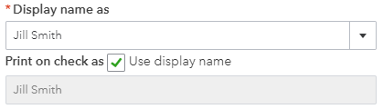

Creating the Report
As of Fall 2024, there are two versions of the transaction detail report, the Classic and the Modern versions. Either version works well with the PositivePay Creator.
Instructions for both versions of the report are included on the following pages. You only need follow one set of instructions and create one of the reports.

Classic View instructions
Create and save the Transaction Detail report – Classic View:
- Start at Reports in the left navigation bar, then pick the Reports sub-menu.
- Run the Transaction Detail by Account report. Find it in the For My Accountant reports section, or type the report’s name in the Find Report by Name field.
- If you see it, click the Switch to Classic View button at the top of the report.
- Click the Customize button
- Click Filter
  - Next to Transaction Type, pick all types of checks, usually including these:
Check, Tax Payment, Sales Tax Payment, Bill Payment (Check), Liability Payment (Check), Paycheck, Payroll Check
  - Select the Account filter and choose the desired bank account.
  - Select the Distribution Account filter and then choose the same bank account.
- Click Rows/Columns
  - Under Group by and pick None
  - Click Change columns.
    - Remove the following unneeded columns:
      - Class
      - Split
      - Balance
    - Add the following required columns:
      - Account
      - Clr
- Run the report.
- Make sure the report contains these columns:
  - Date, Transaction Type, Num, Name, Memo/Description, Amount, Account, Clr
Your report should look like this:
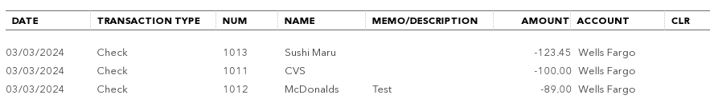
(Note that the columns can be in any order.)
- Click Save Customization.
As you save the report, give it a name that us, such as PositivePay Check Detail.

New View Instructions
- Create and save the Transaction Detail report – Modern View:
- Start at Reports in the left navigation bar, then pick the Reports sub-menu.
- Run the Transaction Detail by Account report. (Find it in the For My Accountant reports section, or type the report’s name in the Find Report by Name field.)
- If you see it, click the Switch to Modern View button at the top of the report.
- Click Filter and add two filters:
  - Pick Transaction Type, select equals for the Operation, then open the Value drop down and add a checkmark next to all types of checks, usually including these:
Check, Tax Payment, Sales Tax Payment, Bill Payment (Check), Liability Payment (Check), Paycheck, Payroll Check
  - Click Add Another Filter
  - Pick Account, select equals for the Operation, then select the desired bank account.
- Click Group by.
  - Click Clear all.
- Click Columns.
  - Remove the following columns
    - Account Full Name
    - Balance
  - Add the following columns
    - Cleared
- Make sure the resulting report has these columns:
  - Account, Date, Transaction type, Num, Name, Memo/Description, Amount, Cleared
Your report should look like this:
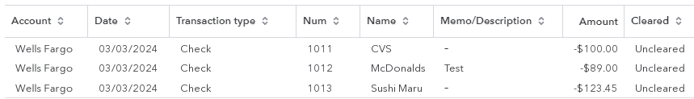
(Note that the columns can be in any order.)
- Click the Save As button
As you save the report, give it a name that us unique, such as PositivePay Check Detail.

Run and export the report
After saving your report, you can run it from the Custom reports are of the reports feature to pull your current transactions for your PositivePay file.
To run your report:
- Click Report and then choose Reports
- Click the Custom reports tab.
- Pick the report created in the preceding section, perhaps named PositivePay Check Detail as suggested.
- When the report displays, adjust the date range for the desired period.
- Click the Export button or icon at the top of the report, and choose Export to Excel.
- Save the report in the desired location.
Report Location: For your sanity, we recommend creating a folder for just these reports in your Documents folder. Name it PositivePay Reports or similar.

Create a Positive Pay file from your QuickBooks report
If it is not already running, launch the PositivePay application, which will look something like this, depending on the selected Bank file format:
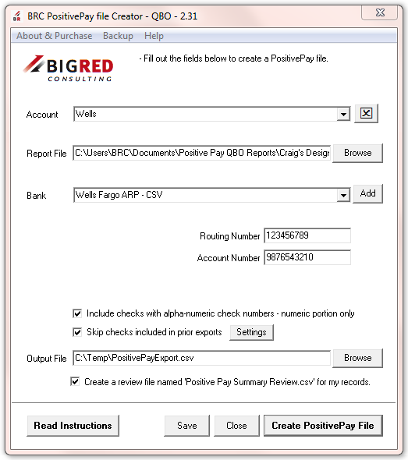
To create a positive pay file:
- Select or enter an Account name or add one to the list for the account you’re currently working with. Give it a name you’ll recognize later, such as the name on your Chart of Accounts.
- Pick the desired Report File, probably the file just created and exported from QuickBooks Online.
- Select a Bank file format from the list.
- After you select the Bank file format, data fields required by your bank, if any, will appear. Enter the requested information, which is most often your bank routing and/or account numbers.
- Give the output file a name and location.
- Consider selecting the option to create a review file – which is human-readable and suitable to print. It details the checks included – and excluded – from the PositivePay file, along with reasons for the exclusions.
- Click Create PositivePay File to create your file.

What is included in my positive pay file?
The PositivePay creator reads the detailed rows of your QuickBooks report and from each acceptable row creates an entry in your positive pay file.
Depending on your bank’s requirements it includes all checks from your report that are not cleared and have check numbers. Some banks include voided checks in their files and others do not.
To help you review the checks that are included in your file, select the “Create review file…” option. You can then open that file in a text editor or spreadsheet program like MS Excel for review.
Skipping checks previously exported
Some banks will issue errors if you send the same check more than once.
If this is the case with your bank, then to make sure you don’t send the same checks twice, select the option “Skip checks included in prior exports.” You can review the checks that are remembered as being previously exported by clicking the Settings button, after which you’ll see a dialog window like this:
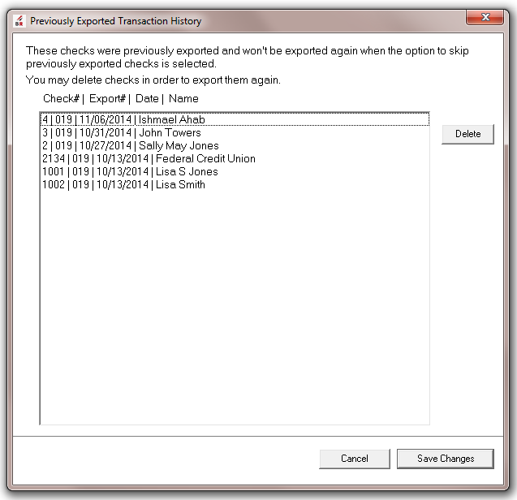
On this dialog:
- The Export # is an automatic sequence number.
- You can remove checks from the list by selecting a check and clicking Delete. When you do then the deleted checks will be exported again and then added back to the list.
Creating a Custom File format
In addition to picking banks from the bank list, you can also create a custom CSV or fixed field length file. To create a new file format, click the Add button next to the Bank pick list. You’ll then see this dialog:
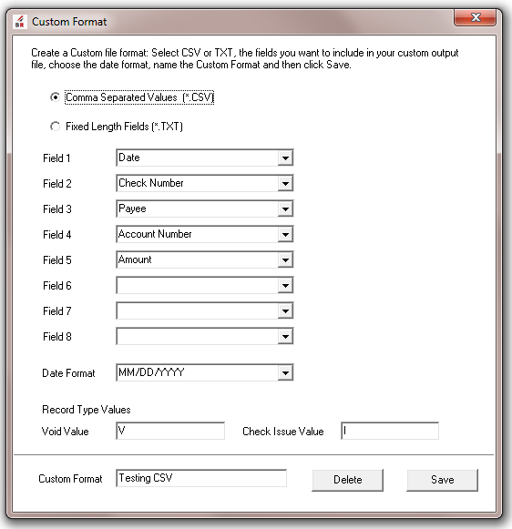
To create your custom format, pick either a CSV or fixed length file format, and then from the available field values for each Field 1 – 8 (you can leave some fields blank.)
If you pick CSV, then fields are included in their entirety, with commas in-between.
- Fields are not truncated (and you don’t specify the length.)
- If you skip fields (say you specify fields 1 and 3 leaving 2 blank), then the field is skipped.
If you pick Fixed Length, you then can specify a field length for each field and it will always be that length adding padding to the field or truncating it as needed to make it the length you enter.
- Numeric fields like the Check Number and Amount are automatically right justified and zero filled, while text fields like the Name and Memo are left justified and blank filled.
- Date field lengths should always be the same as the length of the Date Format field, and the form tries to make that happen automatically.
- If you skip fields (say you specify fields 1 and 3 leaving 2 blank), then the field is skipped.

Handling Voided transactions
When working with QuickBooks data, voided checks pose a particular challenge. This is because when you void a check in QuickBooks, its amount becomes 0.00. However, many banks want you to report the original amount of the check to help them match the check in your PositivePay file with a check that may be presented to them.
Note that some banks expect voided checks as described in this section, and some will treat these as STOP payment requests. See the section below, and yet others use a CANCELED concept. Be sure to read all three sections to see how things are handled for your bank.
To handle Voided checks for most banks (and STOP transactions for others) follow these steps:
- Void the check as normal in QuickBooks, using the Void option from the menu. This step makes it visible to the PositivePay Creator as a voided check.
- Edit the check’s memo and add the original amount to the memo immediately after the first word in the memo, which must be “Voided:” Once you do this, the check memo should look something like these examples:
  - Voided: 12.34
  - Voided: 23.45 Other memo text here
Make sure that the amount you add has spaces before and after it, that it is the second ‘word’ in the memo.
The memo on the check should look like this on the check:
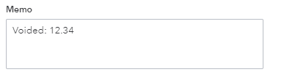
- Save the check. Repeat these steps for each Voided check that should be included in your file.

Handling Stop transactions
When working with QuickBooks data, sending STOP transactions is a form of a void, as described in the previous section.
This section applies to the following bank selections:
- Citibank - CitiDirect SDR
- Citibank - CitiDirect NA
For only the banks in the preceding list:
- Voided transactions are those that were never issued and so will never be presented to the bank. For example, a misprinted check. To indicate a voided transaction, void the check in QuickBooks as usual and then do NOT enter the original amount in the Memo field.
- STOP transactions are those voided checks that you actually issued and then voided and you don’t want the bank to pay them. To indicate a STOP transaction, void the check in QuickBooks and then follow the steps in the voided section of this documentation.

Handling Canceled transactions
When working with QuickBooks data, sending CANCELED transactions is a form of a VOID, as described in the previous section.
This section applies to the following bank selections:
- Wells Fargo ARP – CSV
- Wells Fargo ARP - Standard
For only the banks in the preceding list:
- VOID transactions are those that were never issued and so will never be presented to the bank. For example, a misprinted check. To indicate a VOID transaction, void the check in QuickBooks as usual and then do NOT enter the original amount in the Memo field.
- CANCELED transactions are those voided checks that you actually issued, and then uploaded to the bank, and then voided and you don’t want the bank to pay the check. To indicate a CANCELED transaction, void the check in QuickBooks and then follow the steps in the voided section of this documentation to add the original amount to the check. It will then be coded as CANCELED.

Common Questions
This section addresses common FAQ’s not covered above:
Question: Will the PositivePay creator work with my bank?
Answer: Yes, it will work with your bank if your bank is on the list or if they accept a simple CSV or fixed field length TXT file with just check records.
Question: What if my bank is not on the list?
Answer: You can try creating a custom file format. If you are unable to create a customer file for your bank (e.g. the bank needs more fields), please email us and request that we add your bank to the list. If you have the bank’s file specification then please send it, because that will speed up the process (It is often hard for us to get the bank spec document from the bank because we don’t have an account with them.)

Install, Purchase, and Register
This is an overview of various utility operations you may want to complete when using the product. The later sections in this document cover the steps for using the product.

Installing the add-in
If you downloaded the installer and ran it, and are reviewing this document from the Start menu or from the Help button from within the add-in, then installation is complete.

Trial Period
When first installed, the add-in is in “trial” mode. In trial mode and will work for 30 days once you first used it. See the About & Purchase dialog for information on the current state of your trial.

Purchase & Entering your Product Key
To purchase the add-in, go do our site at www.bigredconsulting.com and click a Purchase link on the Positive Pay creator’s home page.
You will receive an email with your receipt & Primary product key.
When you receive your product key, click About & Purchase at the top of the add-in’s main dialog window and then enter your key.
Note: You may copy the key from the email or web page and paste it in the key field: Use Ctrl-C (or right-click Copy) to copy the key & then paste it into the About & Purchase dialog using the shortcut key Ctrl-V.

Moving to a new computer
To move to a new computer, the basic steps are to install the PositivePay app there and then to copy your settings from the old computer to the new computer
The best-practice steps are:
On the current computer
- Click Backup on the menu and then Export Settings. Create the file, noting the location. The default file name will be BRC PositivePay Creator QBO Settings.DAT.
- Copy the *.dat file to the new computer.
On the new computer
- Install the PositivePay Creator. You can get the latest installer from our site from this page: Get the Newest Product Build
- Click Backup on the menu and then Import Settings. Locate and import the settings file.

