
Donor Statements – QB Desktop
Introduction
Thank you for using the Donor Statements add-in, by Big Red Consulting.
We’ve written this document to ensure you have a smooth start when using the add-in, to provide both an overview as well as detailed instructions, and to address frequently asked questions.
For best results, and to make the best use of its various features, we recommend printing this document for easy reference and then reviewing it completely.
The Donor Statements add-in works within Excel as an Excel Add-In. It creates a special Ribbon tab to access its features, which is used to create donor statements.
It requests donation data directly from QuickBooks and uses it to create letter-style statements in Excel. You can print paper statements for mailing or email them directly to your donors - when using it with our Excel Batch-Email Manager add-in.

Please note:
QuickBooks is a registered trademark of Intuit, Inc.
Microsoft Excel is a registered trademark of Microsoft, Inc.
The Donor Statements, the BRC Excel Batch-Email Manager, and this document are copyrighted by Big Red Consulting.
Table of Contents
Quick start Overview 3
Getting ready to create statements 3
What can be included on statements? 4
Creating statements 4
Pulling QuickBooks Data 4
Customizing your statements 8
Account Filter 8
Item Filter 9
Donor Filter 9
Other Filters 10
Presets 13
Contribution Tables 14
Message Text 15
Logo and Signature Options 16
Font Selection 17
Addresses Alignment – for windowed envelopes 17
Delivery – Print or Email 18
Statement Options 19
Custom Text Features 23
Text Formatting – bold, italic, and underlined 23
Auto-replace Key Words 24
Conditional text 26
Use First 27
Use First and Conditional Text together 27
Aligning statement data 28
Printing statements 29
Emailing Statements 30
Email Statements using the Excel Email Manager 30
Email Settings - Field by Field 31
Mail Merge Table 32
Creating a mail merge summary table 32
Housekeeping - Installing & Purchasing the Donor Statements 33
Install the add-in 33
Load the App as an Excel add-in 33
Trial Period 33
Purchase & Enter your primary product key 33
Moving to a new computer 34
FAQs 35
Troubleshooting 35
Getting Data from QuickBooks 35
Appearance of Statements 36
Example Statement 37

Quick start Overview
To create donor statements, make sure QuickBooks is running with your company file open and then click the Create giving statements button on the Ribbon - or menu, when using older Excel versions.
The custom Ribbon tab looks like this in Excel:
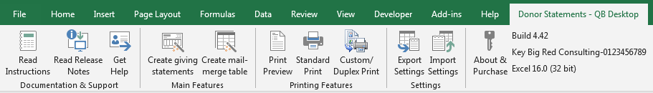
Generally, the features are orgainized from left to right in the order you might use them:
- Documentation & Support: A link to these instructions, another to check for updates and read release notes, a way to get help by creating a support request on our site.
- Main Features: Create statements and/or a mail merge table that includes statement data.
- Printing Features: Shortcuts to Excel’s Preview and standard printing features and the Custom/Duplex printing feature we’ve created just for statement worksheets.
- Settings sections to export/import your settings, to purchase and enter your product key, and a display of your current build, your primary key, and the Excel version you’re using.
When creating statements, you will first pull data from QuickBooks. Next, you’ll be presented with a multi-tabbed dialog window that offers options & settings to help you create statements to suit your needs.
If needed, you can create statements over and over, refining your settings, without pulling data from QuickBooks again, until your statements are just the way you like them.
When your statements print/preview as desired, you’ll be ready to print or email them. If printing, you can use the special Custom/Duplex print feature to save paper. It also features several other useful options Excel doesn’t normally offer.

Getting ready to create statements
What do you need to create statements? Here’s a rundown:
- Your donation data is entered in QuickBooks in a way the Donor Statements will recognize it. Basically, this means that your donations are entered using sales forms like Sales Receipts and Invoices, or directly as Deposits, or even as Journal entries.
- Excel and QuickBooks are running on the same computer.
- If emailing statements, Excel Batch-Email Manager - offered on our site - is installed and configured.
- If printing statements, we recommend using windowed envelopes - which is optional.
The add-in is designed to create statements that can be tri-folded and stuffed into #10 windowed envelopes, so no labels or manual addressing is required. This reduces the time spent matching the labels to statements and eliminates the possibility of sending statements to the wrong donors.
- Also recommended:
  - Log into the QuickBooks company file as the Admin or Accountant user to ensure you have rights to all then rights needed to get the required data.
  - If you need to switch company files before creating statements, do that and then restart QuickBooks to avoid possible connection errors caused by switching company files.
  - Switch to single user mode to increase performance.

What can be included on statements?
This Donor Statements requests donation data directly from QuickBooks and creates a new Excel workbook for the data. It then creates your donor statements from the QuickBooks data.
Sales Receipts, Deposits, Invoices and Payments, and Statement Charges are requested by default.
You can optionally request Journal entries to be included.
You can also optionally request Invoices (“Pledges”) and include them on your statements in their own table that shows the original amount of the pledge and the remaining balance.

Creating statements
The process to create statements can be divided into two steps: Pulling the donation data from QuickBooks and then using it to create statements.

Pulling QuickBooks Data
To start the process to create statements, click “Create giving statements” from the Ribbon or menu.
A dialog window will appear where you can specify Data Options and the date range for your statements:
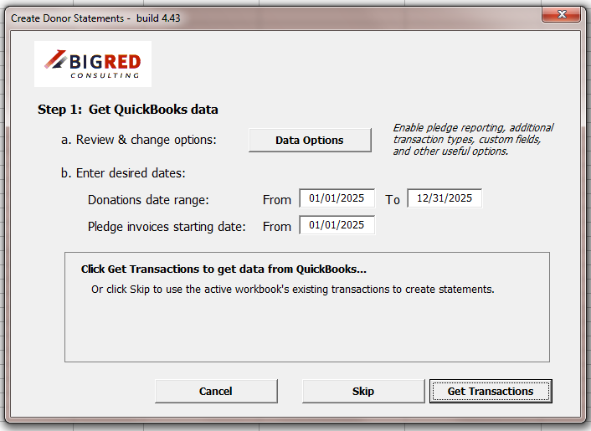
Before creating statements, review the Data Options to make sure they match how you enter your donations and the data you want to appear on your statements. For example, the Data Options window offers the option to enable pledge reporting.
Be sure QuickBooks is running and that you’re logged into the company file using either the Admin user, the Accountant user, or another user who has full rights to all data. Otherwise, you may see error messages or QuickBooks may return some data, but not all the data needed for your statements.

Data Options
The Data Options window has three tabs.
The Data Types tab lets you pick the transaction types to include. Pick the transactions types you use for donations. Also, decide whether or not you want to pull pledge data from QuickBooks.
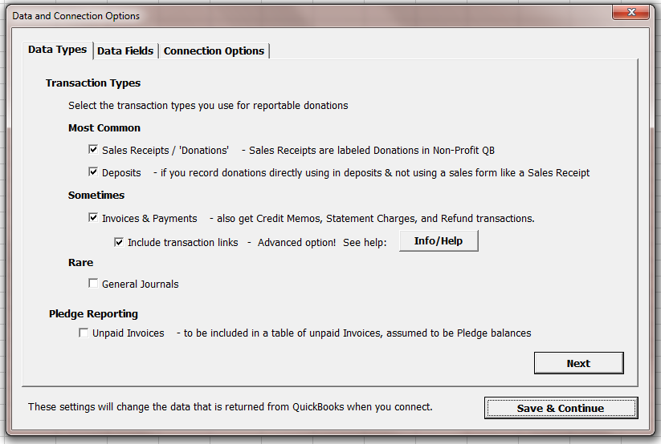
The Data Fields tab lets you include more or fewer data fields, as needed.
You can enable shipping address fields – either the 5-row address block or the parsed version of the fields. These fields can then be included in your custom text and your detail tables.
You can also request the custom fields and their data as entered on your donor name records.
Last, you can specify custom fields. This option will return the data that is entered on sales transactions in the custom fields.
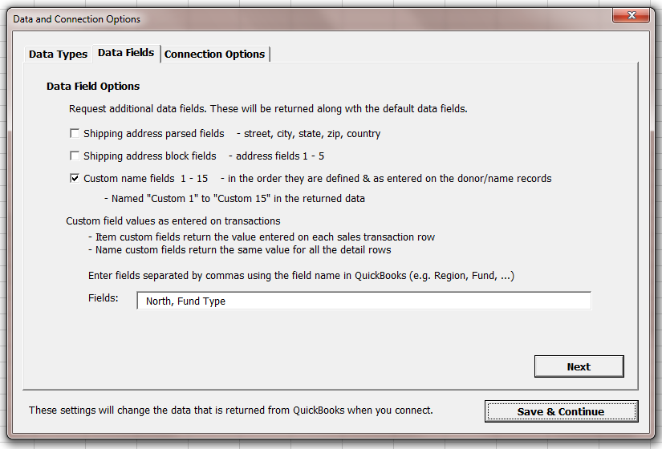
The Connection Options tab offers the option to break up the data request into intervals. This is useful for large data sets where it is usually faster than requesting all of the data at once.
The alternate connection method is enabled by default and recommended.
In most cases you won’t need to change the temp file folder, but it can come in handy in some cases, such as when there are issues when creating and deleting files in the default folder.
The Items lookback period is used with QuickBooks 2022 and newer, because these versions won’t return the items list directly.
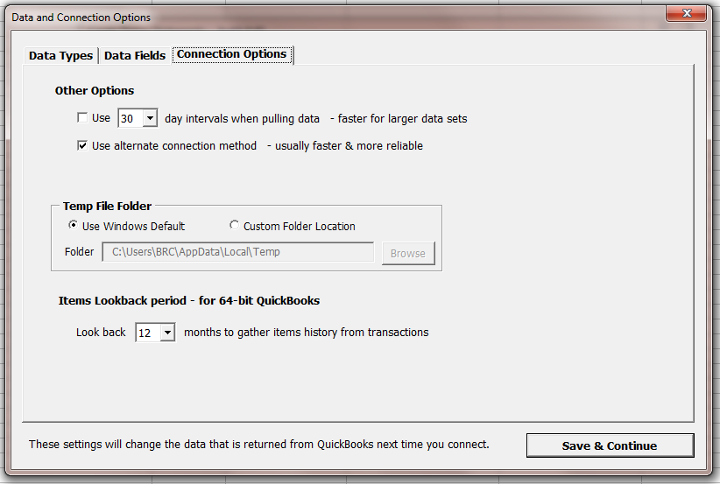

Customizing your statements
After your donation data is retrieved from QuickBooks, you are presented with a multi-tabbed window that contains filters and other options you can set for your statements. There are many options designed to meet various needs. Most settings have defaults that work well for most users.
Settings can be separated into two types: Filters that restrict the data that’s included on statements, and settings that impact the way the statements appear.
- Filters work together to select from your data your reportable donations.
- Appearance settings let you set the text to include on your statements, the fonts to use, a logo and signature, columns to include on your detail tables, as well as other settings.

Account Filter
Select the accounts that you use for donations. This filter can help to include only reportable donation details and exclude transactions or part of transactions that shouldn’t be reported - those that use non-donation accounts. For example, a sale of goods or services.
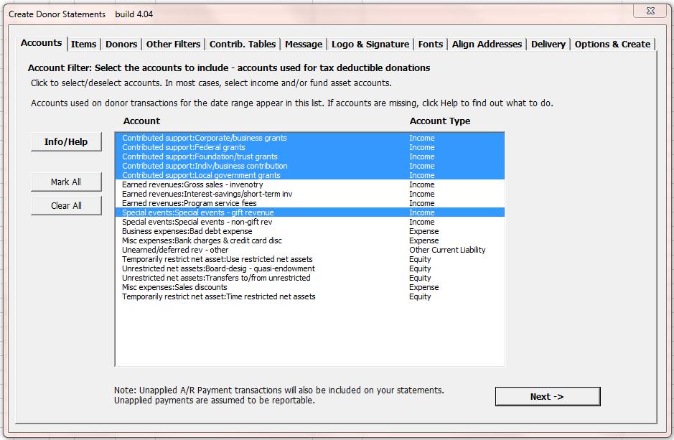

Item Filter
Filter the data by Item.
Note that the various filters are cumulative and work together to select (and to exclude) transaction data. As with the Other Filters, if you set the Items filter it further excludes data.
As a result, you can accidently exclude all of your data. For example, you can pick a donation account to include and then pick only items that don’t use that account. This will exclude all of your data.
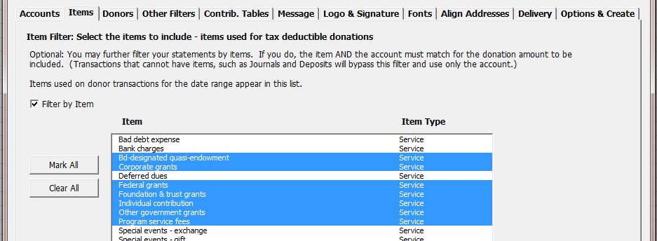

Donor Filter
Select All Donors or select specific donors. You can manually select donors one at a time and also “auto-select” them based on properties like the customer sub-type. You can also auto-select based on email address (has and doesn’t have), which is helpful when emailing statements, because you can then run a batch of statements for donors without an email (to print) and then another batch for donors with email address (to email.)
Use the Name detail level option to create individual statement per Customer:Job, or one statement for a donor with multiple Jobs.
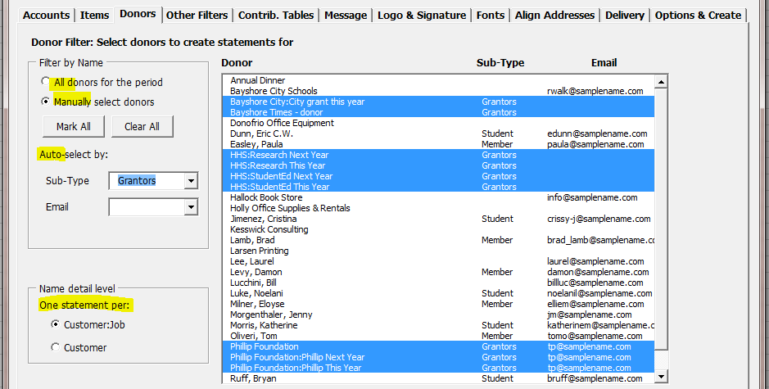

Other Filters
The various filters on this tab and its sub-tabs include filtering by the total donation amount, the donor’s AR Account Balance, a secondary date filter, a class filter, by the payment method used, whether or not the donor has a complete address.

Donation Amounts
Filter based on the total amount of the donations or based on a single amount.
Also seen in this screenshot, you can use testing mode tio limit the number of statements that are created, which can be useful as you refine your statements.
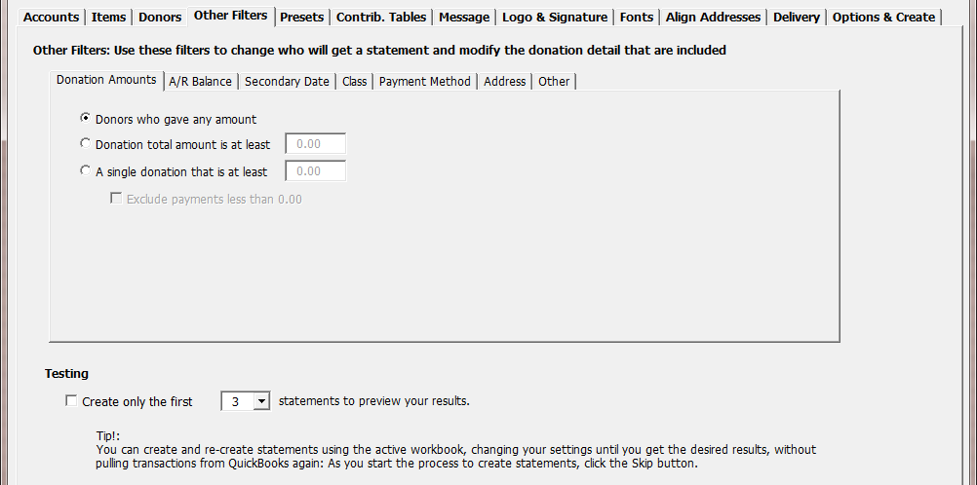

A/R Balances
Filter based on the donor’s account balance.
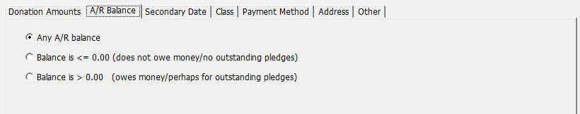

Secondary Dates
Set the secondary date filter to print statements only for donors who gave within a smaller date range – compared to the the data requested from QuickBooks.
Optionally, include details only from the restricted date range or from the entire date range - when the last option is de-selected.
This allows you to, for example, create statements only for the donors who gave in July - but at the same time include all of their YTD donations on statements.
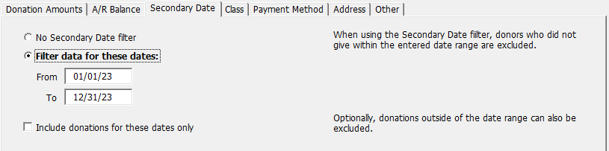

Classes
Filter the donations based on the Class records used on each transaction - or on each donation detail row when entering classes on detail rows.
Use “No Class” to include transactions that don’t have any class specified.
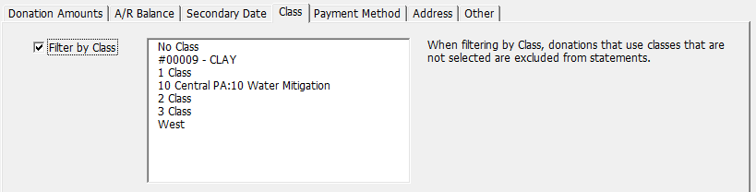

Payment Methods
Filter the donations based on the Payment Method used on each donation.
- For Sales Receipts and Payment transactions, a single payment method used on the transaction applies to the entire transaction.
- For Deposits, each detail row has a payment method.
Use “No Payment Method” to include transactions that don’t have any payment method specified.
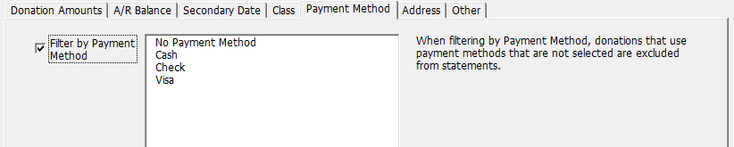

Addresses
Filter based on whether or not the donor has a complete address, which can be useful to exclude donors where you don’t have an address – since you can’t mail the statement in any case.
Filter by the Country in the case where you want to include or exclude countries from your mailling.
You can also select the Ignore these filters when emailing statements options, which is helpful because when emailing the postal address doesn’t really matter.
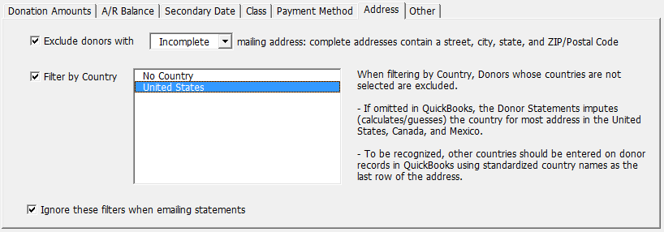

Other
These settings can help you further filter the donors and donation details that will be included.
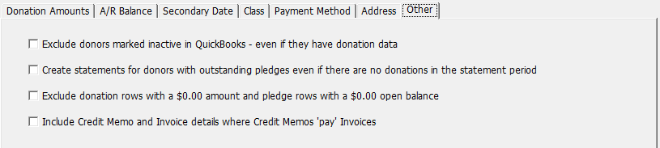

Presets
A newer feature that preconfigures the tables, fonts, and some other settings to make it quicker to set up your donation details tables to suit your needs.
Select from the different presets from the list to get a preview and description of the preset style.
To use a preset, click the Apply Preset button, which will update some of the settings on the following tabs including the contribution table and font settings.
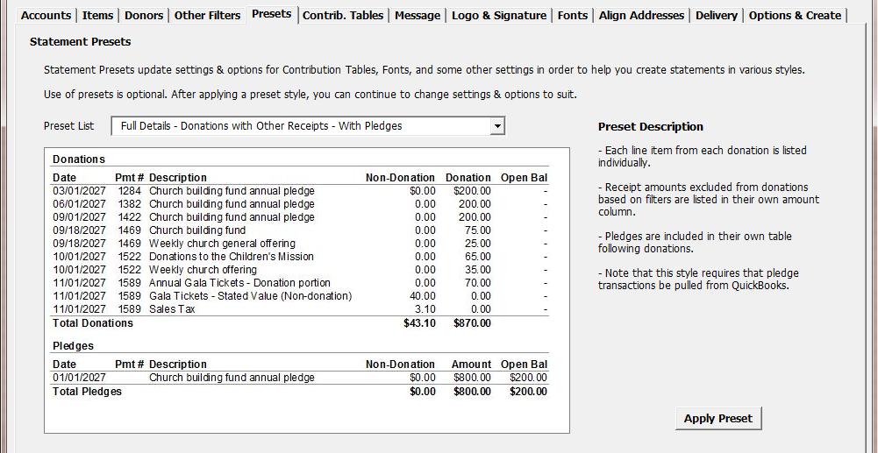

Contribution Tables
There are three options for contribution/donation tables: A summary table, a detail table, and no table.

Summary Table
The Summary table offers two options, one to combine donations on the same date and the other to specify the date format. It creates a table of donations in a grid that will look something like this:
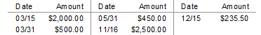

Detail Table
The most commonly used option is a detail table, which offers many customization settings.
You can, for example, select any of the columns returned from QuickBooks.
Subtotaling
When you subtotal, the donation data is automatically sorted and grouped by the subtotal. You can subtotal on most any field returned from QuickBooks. You may also elevate some records to the top of the list. To do this, click the sort button next to the Subtotal by list and then select the record or records you want to appear first.
Merging
You can choose from options to merge each donation’s details into a single row/amount, merge multiple donations into a single row, or merge all the donation detail as much as possible - given the columns selected for display.
You can also include a second table of pledges, which will appear just below the donations table.
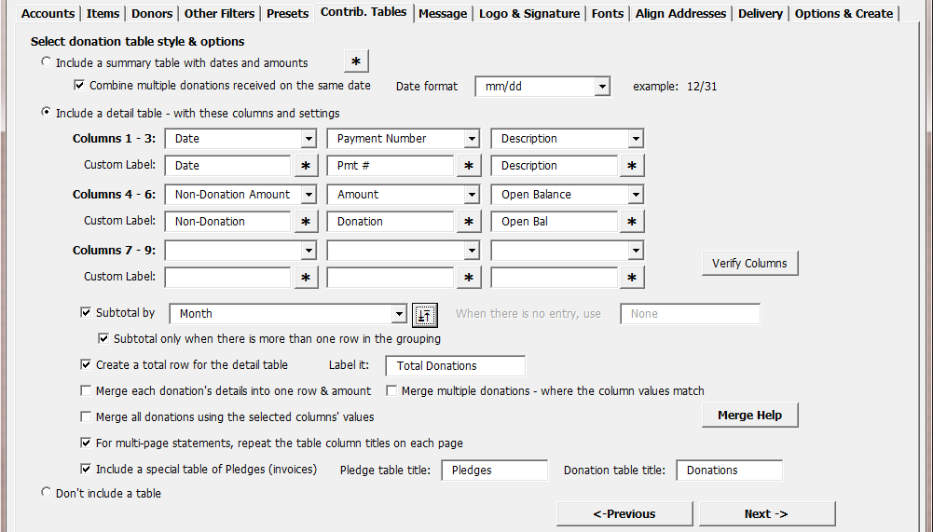

Message Text
Include custom text on your statements.
The custom text fields support auto-replace keywords as well as the ability to format text, make text conditional, and pick from a list of keywords using only the first value found.
See the Custom Text Features portion of this document for instrutions.
The footer text can be included within Excel’s footer (recommended) on the excel worksheet just after the closing paragraph(s).
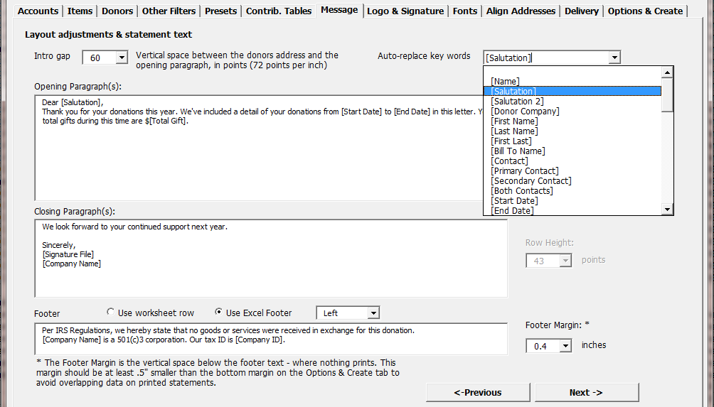

Logo and Signature Options
Specify logo and signature image files to be included on your statements.
The logo can be positioned at the top of each statement on the left, center, or right. The signature will appear as part of the closing paragraph field.
Use the Auto-fit options to automatically set the image sizes.
Use the Adjust Aspect Ratio option if the images appear distorted, either too tall or too short, when you print statements. This setting changes how the images are scaled and as a result they’ll appear distorted on your monitor but will then print as expected.
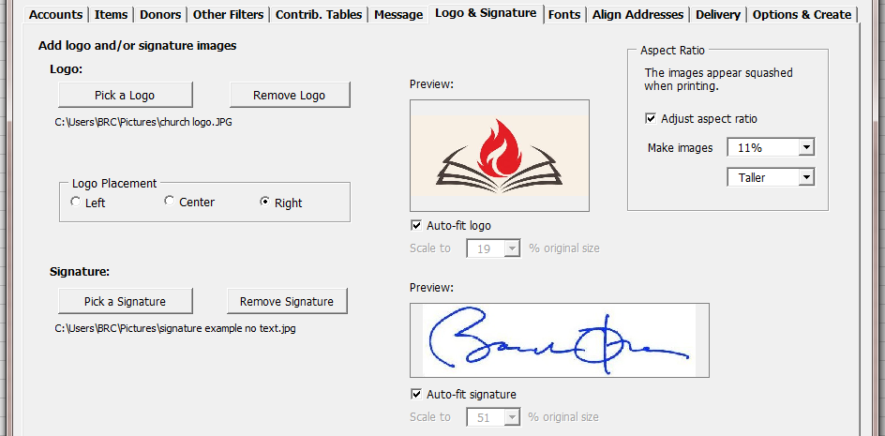
The Adjust Aspect Ratio option was added because Excel has a long-standing printing issue where it alters the aspect ratio of images and charts as it prints them. So, even though the image looks correct on your monitor, it prints incorrectly.
Unfortunately, it doesn’t do this in a predictable way and so we can’t automatically adjust for the issue. Instead, printed results vary from computer to computer based on each computer’s environment. On some computers, the distortion is slight and barely noticeable, and other others it is more extreme. Also, in some cases the image will appear too short and on others it will appear too tall.
Luckily, it also appears that the behavior is consistent over time on each computer, so that once the correct aspect ratio adjustment is set your images will consistently print correctly - though they will look distorted on your monitor.
To get the aspect ratio correct for printing on your computer, create statements repeatedly, changing the percentage setting with each pass. Then print preview or print the first statement page to check the results. If your images appear too short, pick the “Taller” option. If they appear to tall, pick the “Wider” option.
Usually picking an adjustment value from 1% - 15% is enough precision to make the images print correctly. However, if needed you can also enter more precise values in the field, like 11.5% or 12.25%.

Font Selection
Set the font, font size, and optionally make the font bold and/or italic. Settings are available for various statement sections.
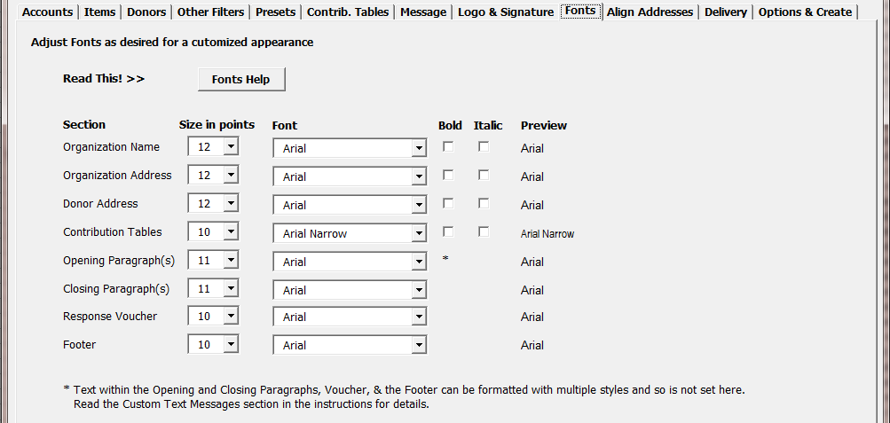

Addresses Alignment – for windowed envelopes
Align the company and donor address fields so they’ll fit properly in windows #10 envelopes.
This is another feature where it can be useful to make a guess and then print a sample statement to checks your results, and then adjust the settings and try again.
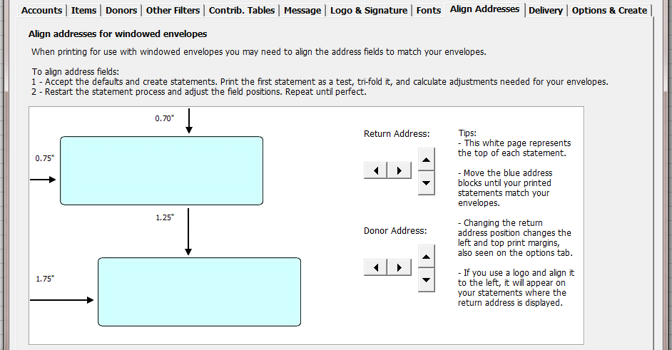

Delivery – Print or Email
Choose to print or email your statements or save them as files.
Chose to create the statements within one workbook for printing, to email them in conjunction with the BRC Excel Batch-Email Manager, or to save each statement as a file.
The latter option to save your files can be useful when creating just one (or a few) statements on special request from a donor, which can then be emailed as a standard email attachment.
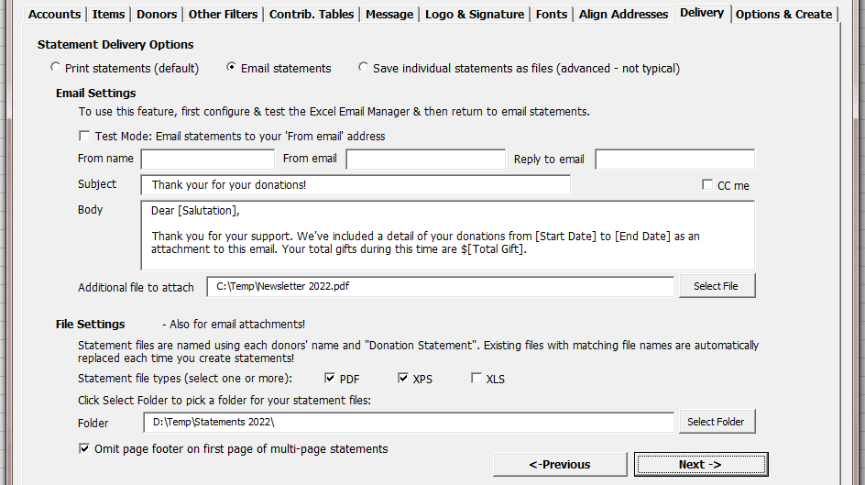

Statement Options
Set various other options for your statements, including statement sorting, numbering statements, including the statement date, setting the margins, and other options. And then (finally!) click Create Statements.
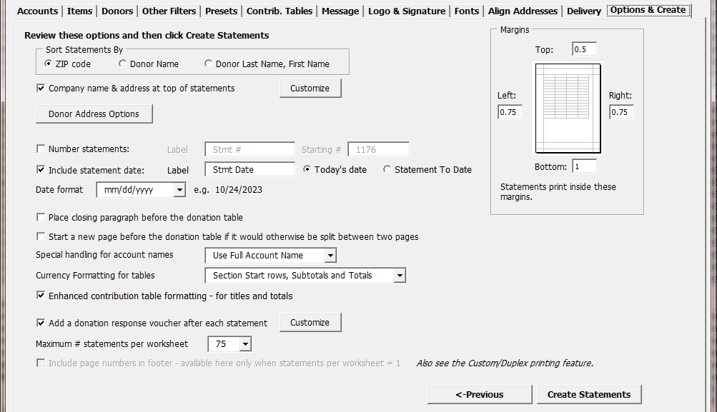
Many of the options here are mostly self-explanatory. A few of them are more involved and are coverted next…

Company Name and Address Options
Use your legal address from QuickBooks or customize the company/charity name and address.
Also, you can sepcify as well as an additional line of text to print under it, such as your phone number.
If the additional line of text is a USPS endorsement then it is automatically bolded and placed about ¼ inch below the company address.
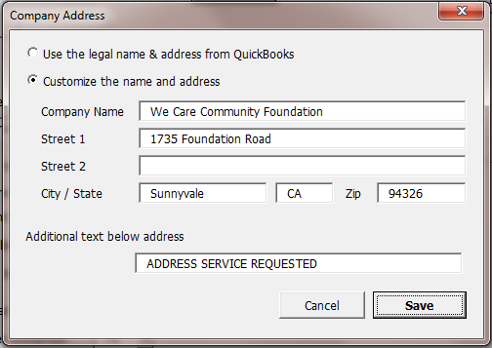

Donor Name and Address Options
Use these settings to change how the donor address appears on statements.
Select the precedence order for the fields from which to populate the [Salutation] and [Salutation 2] fields, when used in the text messages of your statements. For each donor, the first field that has a value is used.
If the Standardize option is selected, the first and optional second salutations are used as the first rows of the address.
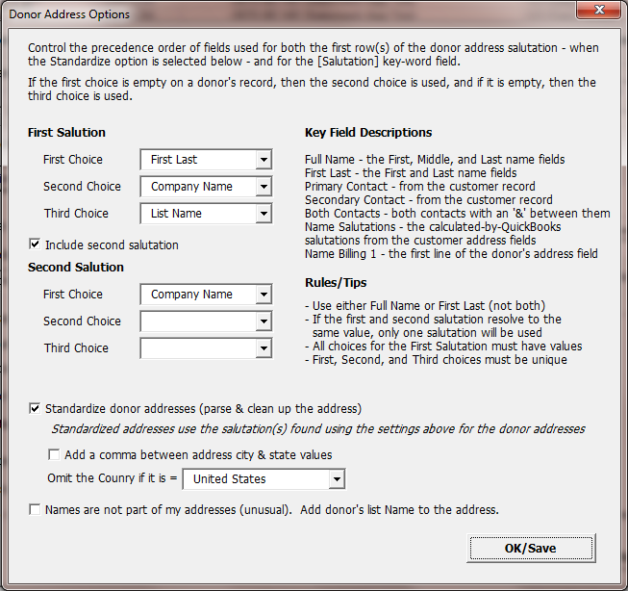

Donation Response Voucher
Add a “tear off” voucher to the end of each statement, either at the bottom of the page or on its own page. It can include the donor’s name and address and most any text you wish, as well as special formatting options.
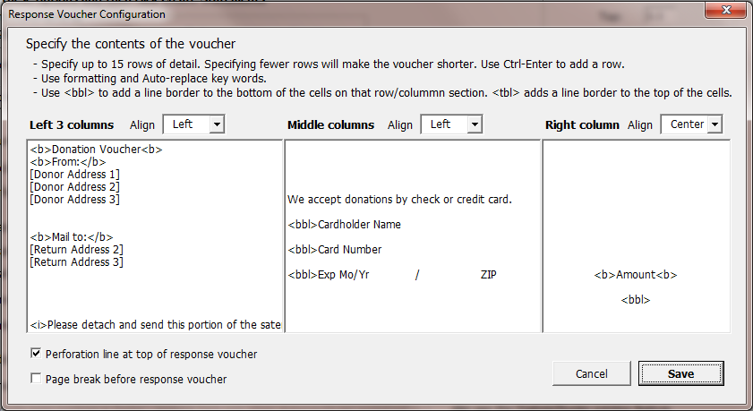
The configuration can take bit of work to get the results you want. The default settings you see above produce a response voucher that will look like this when printed:
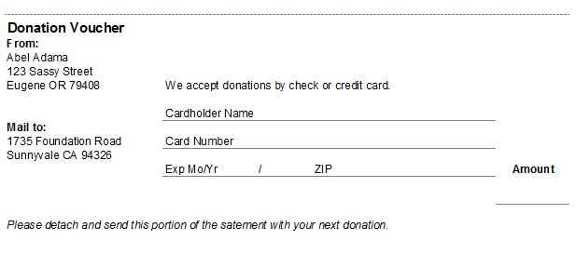

Custom Text Features
Use these custom text features in the Opening Paragraph(s), Closing Paragraph(s), the Donation Voucher fields, and the Footer. Also, when emailing statements, the email Body field is supported.
In these fields, you can specify custom text, custom text formatting, “auto-replace” fields, and conditional text based on auto-replace fields.
Note that after creating statements and reviewing the results, you can re-create statements using the data already pulled from QuickBooks, over and over again, which can help you refine the text on your statements using the features described in the following sections.
To create statements with data already pulled from QuickBooks, make a statement workbook the active workbook and then start the process to create statements. Use the Skip button to bypass pulling data from QuickBooks.

Text Formatting – bold, italic, and underlined
Format text within these fields using html-like code pairs that surround the target text. Use them to bold, underline, and italicize portions of your text messages. Use these keywords:
- To bold text, use <b> and </b>
- To underline, use <u> and </u>
- To italicize, use <i> and </i>
For example, if you specify a sentence like this:
I like to include <b>bolded</b>, <u>underlined</u>, and <i>italicized</i> text from time to time on my statements!
It will appear on your statements like this:
I like to include bolded, underlined, and italicized text from time to time on my statements!
You can use these formatting codes together.
For example, if you specify
<u><i><b>We want it all!</b></i></u>
You’ll get
We want it all!
If you use <b>, <u>, or <i> and don’t include the closing </b>, </u>, or </i>, then the rest of the text will be formatted accordingly.
For donation vouchers you can also use the codes <bbl> and <tbl>, which are used to place a line border at the bottom or top of worksheet cells, to help make the voucher look more like a form. Use <bbl> for a bottom border line and <tbl> for a top border.

Auto-replace Key Words
Auto-replace keyword fields use keywords that are surrounded with square brackets. When you use them, the field is replaced with the value appropriate for each donor based on your QuickBooks data. For example, if you enter [Name] as part of your text field, [Name] will be replaced on each statement with that donor’s actual name.
There are two types of keywords:
First, most every data field/column from the QuickBooks data can be used as a key word. The best columns to use are those related to the donor and not the donations. This is because the value from the first row of data found for each donor becomes the replacement value. For example, in the data the donor’s [Name] will always be the same, but fields like [Account] or [Class] can vary per donation.
Second, there is a list of special calculated fields that can be used.
Use any of these special keywords in your text.
Name | Meaning
[Salutation] | This is a special field derived from your data. It uses your settings from the Donor Address Options window to determine the value for each donor.
[Salutation 2] | This is a special field derived from your data. It also uses your settings from the Donor Address Options window to determine the value for each donor.
[First Name] | The donor’s first name as entered from the customer record.
[Last Name] | The donor’s last name as entered from the customer record.
[First Last] | The donor’s first and last names as entered from the customer record.
[Full Name] | The donor’s first, MI, and last names as entered from the customer record.
[Bill To Name] | The first row of the Bill To address block from the customer record.
[Name] | The donor’s list name as seen in the customer center.
[Donor Company] | The donor’s company name from the customer record.
[Contact]  [Primary Contact] | The primary contact from the customer record.
[Secondary Contact] | The secondary contact from the customer record.
[Both Contacts] | Both the primary and secondary contacts. If both exist, then an “&”is placed between the names. If only one contact exists, it is returned.
[Start Date] | The start date for the data retrieved from QuickBooks, or the secondary start date if using the “Show donations for these dates only” option on the Other Filters tab’s Secondary Date sub-tab.
[End Date] | The end date for the data retrieved from QuickBooks, or the secondary end date if using the “Show donations for these dates only” option on the Other Filters tab’s Secondary Date sub-tab.
[Total Gift] | The total amount of the donations for the period of the Start Date to the End Date.
[Primary Start Date] | The start date for the data retrieved from QuickBooks.
[Primary End Date] | The end date for the data retrieved from QuickBooks.
[Primary Dates Total Gift] | The total amount of the donations for the period or the data retrieved from QuickBooks.
[Total Open Balance] | The total of the unpaid invoices (pledges) for the customer, available when pledge data is included in the data pulled from QuickBooks.
[Company Name] | Your charity’s legal name, from QuickBooks.
[Company ID] | Your charity’s Federal Tax ID.
[Donor Address 1]  [Donor Address 2]  [Donor Address 3]  [Donor Address 4]  [Donor Address 5] | The donor’s address rows as they appear on statements - based on your settings. Primarily used for the Donation Voucher.
[Return Address 1]  [Return Address 2]  [Return Address 3]  [Return Address 4]  [Return Address 5] | Your charity’s address rows as they appear on statements.  Primarily used for the Donation Voucher.

Conditional text
The conditional text feature works with the auto-replace fields. It allows you to make parts of your text message fields display on statements if all of the auto-replace fields within the conditional text sections return non-empty values, or non-zero values for amount fields.
To specify conditional text, surround the target text with the tags <cutempty> and </cutempty>.
Example:
<cutempty>Thanks for your pledge, which has a balance of [Total Open Balance].</cutempty>
If the Total Open Balance is 0.00, then the entire section of text is omitted.
If the conditional text stands alone as its own paragraph, then for best formatting you may want to put the tags on the preceding or following rows. This will avoid a large empty space on the resulting statement.
Four examples:
- This text will result in three empty rows between paragraphs if the open balance is 0.00:
Thank you so much for your total donation of [Total Gift].

<cutempty>Also, thank you for your pledge, which has a balance of [Total Open Balance].</cutempty>

We look forward to your continued patronage.
- This text will result in one empty row between paragraphs:
Thank you so much for your total donation of [Total Gift].
<cutempty>
Also, thank you for your pledge, which has a balance of [Total Open Balance].
</cutempty>
We look forward to your continued patronage.
- This text will result in one paragraph, if the open balance is 0.00, and three paragraphs if it is not:
Thank you so much for your total donation of [Total Gift]. <cutempty>
Also, thank you for your pledge, which has a balance of [Total Open Balance].
</cutempty>We look forward to your continued patronage.
- This text will result in one paragraph, either if the open balance is 0.00 or if it is not:
Thank you so much for your total donation of [Total Gift]. <cutempty>Also, thank you for your pledge, which has a balance of [Total Open Balance]. </cutempty>We look forward to your continued patronage.
Rules
-If there is no [keyword] between the conditional tags, the text will always remain.
-If there are two or more key words between the conditional tags, then if any of them are blank, all of the text is removed.
- If an opening tag is not followed by a closing tag, and there are no closing tags then there is no effect on the text. If there are multiple opening tags followed by a closing tag, the first opening and first closing tag are paired and all the text between is considered together and omitted together.

Use First
The Use First feature allows you to list two or more auto-replace fields in a row and include only the first non-empty (or non-zero) value on your statements.
Using the Use First feature you can control how your statement salutation (and other text) appears.
To specify a sequence of Use First key words, surround the target text with the tags <usefirst> and </usefirst>.
Example:
Dear <usefirst>[First] [Donor Company] [Contact] [Salutation]</usefirst>,
Using this example, if the donor record has a first name, it will be used. If not, then if the donor has a Company Name it will be used, and if not then if they have a Contact name it will be used. And then finally if all of those fields are blank the special salutation field will be used.
Note that the resulting text is ‘managed’:
- Spaces are inserted before and after key word results.
- Double spaces are removed.
- A single space character - if used - after <usefirst> or before </usefirst> is retained.
This means that the following text in your message fields will have the same results on your statements:
<usefirst>[First][Donor Company][Contact][Salutation]</usefirst>
<usefirst>[First] [Donor Company] [Contact] [Salutation]</usefirst>
<usefirst>[First] [Donor Company] [Contact] [Salutation]</usefirst>
It also means that the following text examples will have different results, because of the spaces in the second example, just after <usefirst> and before </usefirst>.
<usefirst>[First][Donor Company][Contact][Salutation]</usefirst>
<usefirst> [First][Donor Company][Contact][Salutation] </usefirst>

Use First and Conditional Text together
You my use the <cutempty> and <usefirst> features together in the same text fields.
They can be used in different parts of the text, or you can include <cutempty> within <usefirst>!
For example, if you want to use a customer’s first name if they have one, and otherwise use the company name, and if you want the extra text “friends at” when using the company name, something like this will work:
Dear <usefirst>[First Name]<cutempty>friends at [Donor Company Name]</cutempty></usefirst>,
Using this example, if there is a first name then you’ll get a salutation like:
Dear John,
And if there isn’t a first name but there is a company name, then you’ll get a salutation like:
Dear friends at Acme Construction,
Aligning statement data
The Donor Statements add-in can be used to print or email statements. When printing, it is intended to create statements which can be tri-folded and stuffed into windowed #10 envelopes, so you don’t need to manually address your donation statements or even print and affix mailing labels.
To fine-tune alignment settings, we suggest creating a trial run where you print one statement from those created. To do this, first create statements as usual. Then print just the first page and Z-fold it, and check it for alignment with your windowed envelope stock. If needed, change settings then re-create statements and try again.
Custom Alignment Settings
Intro Gap
This is the vertical space between the donor address and the intro paragraph text. The setting is found on the Message tab.
Align Address
This tab lets you move both your company address and donor addresses left or right, and up and down to match your windows envelopes. Changing the return address top margin changes the overall top margin for the statements.
Margins
You can also make adjustments to your statements using the Margins section on the Options & Create tab of the create statements interview.

Printing statements
When printing statements, you can use Excel’s standard print functionality. Or, you can use the special Custom/Duplex print feature we’ve built just for statements.
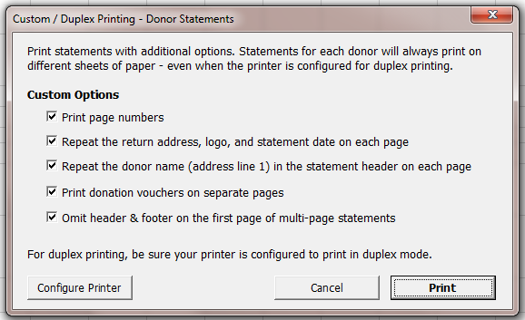
The custom printing optoins work whether or not you have set up your printer to print in duplex mode.
Print Page Numbers
When your statements worksheet contains multiple statements, each statement will start with “Page 1”.
Repeat the return address
When selected, the top of each page of a multi-page statement will iclude your company name and address, your logo, and the statement date.
Repeat the donor name
When selected, the donor’s name will appear in the top right header of each printed page. This can be useful for multi-page statements, to make sure you have the correct pages together.
Print donation vouchers on separate pages
When selected, and when printing in duplex mode the voucher will always be printed on its own piece of paper, and never on the back side of the statement.
Omit header & footer on the first page
When selected, the header and footer are omited of the first page of multi-page statements. The header and footer will still print on the first page of shorter statements that fit on single-page.

Emailing Statements
Donor statements can be emailed instead of printed, saving effort and postage. This is possible when using the BRC Excel Batch-Email Manager, which can be purchased on our site.
There are two ways to email statements:
- Recommended: Email fully-formed statements as attachments directly as they are created by the Donor Statements. When viewed by the customer they’ll look just like printed statements.
- Create a mail merge table and use it to email statements using some other method.

Email Statements using the Excel Email Manager
Use this option to email statements as they’re created from within the Donor Statements.
Statements are created and sent to each donor’s email address as attachments, using email addresses from their customer records in QuickBooks. The email addresses must be valid internet email addresses.
Tips:
- To send a donor’s statement to more than one email address, enter the addresses in the QuickBooks email address field separated with commas, like “john@test.com, jane@test.com”.
- When an email is sent to a donor, it is tracked on the “Email Log” worksheet. If you email statements again from the same Donor Statements workbook, donors listed on the Email Log worksheet will not be sent a statement.
- To email a statement to a donor that has already been sent one, remove their name from the Email Log worksheet.
- Use the “auto-select” feature to quickly select donors with email addresses, or – when printing statements – those that don’t have email addresses.
- As statements are being created and emailed, you can see the progress in Excel’s status bar.
- If there is an error when emailing a statement, you’ll receive an error message with the option to stop emailing.
- You can create and email statements when the Donor Statements and Email Manager are in trial mode – though you can’t pick who will be sent a statement. We recommend sending statements using the email “Test mode” option during the trial, which allows you to send the statements to yourself for review.

Basic set-up
1. Install and configure the BRC Excel Batch-Email Manager. Test your mail account using the Email Manager’s test feature to be sure it’s working with your mail server. Once working, it’s ready to be used with the Donor Statements add-in.
2. Start the process to create statements. When licensed (not in trial mode), you can manually select donors, including an option to auto-select those with or without email addresses.
3. Select the option to email statements on the Delivery tab, where you can enter the subject and the body of the email, pick the email account to use, and choose other options.

Email Settings - Field by Field
These settings are found on the Delivery tab of the Create Statements window.
Email Test Mode: In test mode, up to three statements are sent and you’re able to specify the address the statements are sent to.
Account: The Email account to use. The email accounts set up in the Excel Batch-Email Manager will appear in the list. Choose any account set up in the Excel Batch-Email Manager.
From name: The name your donors will see.
Reply to: The email address for any replies from your donors (not available in email test mode).
Test email: The email address test emails will be sent to (only appears when in email test mode).
Subject: The subject that the donor will see.
Body: The body of the email.
CC me: Check this box and you’ll receive a copy of each email sent.
BCC me: Check this box and you’ll receive a blind copy of each email sent.
Additional file to attach: Select an additional file to attach to all your emails, such as a newsletter.
File settings
When emailing, you may select one or more of these attachment file types. A statement will be created and saved in each of the selected file types and they will then be sent as attachment(s):
PDF: Creates a standard PDF file attachment.
XPS: Creates a standard XPS file attachment. – The XPS format is used by the Microsoft XPS Document Writer, and all or nearly all Windows machines come with this utility preinstalled, so most all Windows users should be able to open a file in this file format.
XLS: Creates an Excel workbook attachment.
Folder: The folder used to save statement attachments before they’re emailed.

Mail Merge Table
The mail merge table is a completely different way to use the Donor Statements tool. This option is suitable for creating mailing labels or statements for your customers in another application such as Microsoft Word. The resulting mail merge table may also be useful as a data source for other needs.

Creating a mail merge summary table
To start the process to create a mail merge table, pick the option “Create mail merge table” from the custom Ribbon or menu.
The resulting interview to create your mail merge table is similar to the Create Statements window, asking only applicable questions. Some settings are shared with the Create Statements window.
The mail merge feature creates a new workbook containing a worksheet of data where each donor record occupies one row on the worksheet. It contains information such as the name and address, total giving for the matching accounts, and both HTML and text fields containing tables of donation data similar to those included in Excel-based statements.
Once this worksheet is created and saved, you can use it as a data source in Microsoft Word to create mail merge letters or to email the data. See Word’s documentation for steps to use its mail merge features.
When you install the Donor Statements tool, an example Word doc that matches the mail merge data is also installed. It is named “Donations Mail Merge Template”. Using MS Word, you can use it as a starting point for your mail merge process.
Most of the fields are self-explanatory and you can use instructions in the Excel Batch-Email Manager’s documentation to use them as auto-replace fields. These include fields like Salutation and first and last names.
Several fields are special. These contain the detailed donation history for each Donor based on the data from QuickBooks and the accounts and data field selected in the interview.
donation_details_HTML – This field contains an HTML table of the Donor’s detailed history, similar to what appears when you create statements to print. If you include the field in your HTML email body description, you’ll see a formatted table when you review the email in an email program or web service.
pledge_details_HTML – This field contains an HTML table of the Donor’s pledges, similar to what appears when you create statements to print. If you include the field in your HTML email body description, you’ll see a formatted table when you review the email in an email program or web service.
donation_details_TEXT – This field contains a text table of the Donor’s detailed history. It is useful for text email, which is not usually seen by customers unless you don’t setup an HTML email body or the customer has a text-only email reader.
pledge_details_TEXT – This field contains a text table of the Donor’s pledges. Similar to the field above, it is useful for text email, which is not usually seen by customers unless you don’t setup an HTML email body or the customer has a text-only email reader.

Housekeeping - Installing & Purchasing the Donor Statements
This is an overview of various utility operations relating to the Donor Statements Add-in.

Install the add-in
After running the installer, the installation is normally complete and there is nothing more to do.

Load the App as an Excel add-in
If for some reason the Donor Statements is not currently loaded, you may load it from within Excel manually. Once loaded, each time Excel starts the add-in will normally be available until you unload it. To load the add-in, first start Excel & make sure a workbook is open (one usually opens when you start Excel.)
Excel 2010 – 2021:
1. Select File, then Options from Excel's menu.
2. In the Options dialog, select Add-ins.
3. At the bottom of the add-ins pane, select Excel Add-ins and press Go.
4. When the Add-ins dialog opens, click Browse and navigate to the folder where you installed the add-in.
5. Select the *.xla file and then OK to close the dialogs.
Excel 2007:
1. Click the Microsoft Office Button and then click Excel Options.
2. Click Add-Ins and then in the Manage box select Excel Add-ins. Click Go.
3. In the Add-Ins available box, click Browse... and navigate to the folder where you installed this add-in.
4. Select the *.xla file & then OK to close the dialogs.
Excel 2003:
1. In Excel choose Tools | Add-ins from Excel's menu.
2. Click Browse and then navigate to the folder to which you installed the add-in.
3. Select the *.xla file & Press OK to close the dialogs.
At this point, you should see this add-in listed in the Add-In dialog, with a checkmark next to it. Press OK to close the dialog, which will load the Add-In. Once it loads, you’ll see a new Ribbon tab or menu item in the Add-ins tab, or for older versions of Excel a menu to the right of Excel’s help menu.

Trial Period
The add-in will be in “trial” mode until you enter your primary product key. In trial mode, most all features are available, but there are limitations to the number of statements that can be created.

Purchase & Enter your primary product key
To purchase the add-in, select About & Purchase from the custom ribbon in Excel. Click the Purchase button and you’ll be taken to our website to make your purchase. When you complete the purchase, we’ll immediately send an email with your receipt and product key.
To enter your key, choose About & Purchase from the Ribbon and then click the Add Key button to add your key.

Moving to a new computer
To move to a new computer, the basic steps are to install the Donor Statements there and to copy your settings, including custom templates.
The best-practice steps are:
On the current computer
- Download and Install the latest built on your old computer.
- Click Export settings on the Donor Statements’ Ribbon tab. Create the settings file, noting the location. The default file name will be NONPROFNOTICE_Settings.dat.
- Copy the *.dat file to the new computer.
On the new computer
- Install the Donor Statements. You can get the installer again from our site from this page: Get the Newest Product Build
- Launch Excel and click Import Settings on the Donor Statements’ Ribbon tab and then locate and import the NONPROFNOTICE_Settings.dat file.

FAQs
No statements are created
Make sure your ‘filters’ don’t exclude all of your donation data.
For example, make sure you select all the accounts used on donations, all the donors, and have not set a ‘floor’ amount to exclude small donations. Also, make sure the date range for the statements includes the dates of the data actually requested from QuickBooks in the current statement workbook.
Can I create statements again without connecting to QuickBooks?
Yes, with a workbook created by the add-in open, you can start the process to create statements and then use the “Skip” button to proceed.
I upgraded Excel and the add-in is gone
Each version of Excel has its own list of loaded add-ins. MS calls this a feature. So, when you upgrade Excel, none of your custom add-ins will be loaded. The easiest fix to this is to rerun the installer. If you don’t have it, you can download it again from www.bigredconsulting.com

Troubleshooting
There are two basic problem areas we’ll cover: Problems getting data from QuickBooks and problems with the creation of appearance of the statements when the connection is working fine.

Getting Data from QuickBooks
There are several possible observed issues seen when connecting and getting data from QuickBooks. The basic issue is that the add-in cannot connect to QuickBooks and retrieve data. These are relatively common, and can usually be solved by fixing QuickBooks.
You may see messages that indicate one of these issues:
- No data is returned from QuickBooks
- Data is returned, but not all of the data in the date range is returned
For each of these, here are the steps to solve the issue:
No data is returned from QuickBooks
- Make sure you have applicable data in QuickBooks in the requested date range.
  - Data that is retrieved includes Sales Receipts, Invoices that are paid in the period, Deposits where you record income directly on the deposit, Credit Memos that are applied to something (either an Invoice or a refund) and optionally Journal transactions.
- Rebuild the QuickBooks data file from the QuickBooks File | Utilities menu.
Data is returned, but not all of the data in the date range is returned
- Log in to your QuickBooks company usinf the Admin or Accountant user. Then try again.
- Rebuild the QuickBooks data file from the QuickBooks File | Utilities menu. Then try again.
- If that does not work, uninstall and reinstall QuickBooks.
For more troubleshooting, see Connecting to QuickBooks - Troubleshooting

Appearance of Statements
Fonts appear too small when printing
Fonts may appear smaller than usual when printing if the statement is so wide that Excel must scale it down to fit on the printed page (fit to one page wide.) To change this and reduce the statement width, try these tactics:
- Make the table font smaller and/or narrower than the rest of the statement. Do this in the wizard as you create statements. Arial Narrow can work nicely.
- Make the text font for the paragraphs of text larger, while leaving the table font as-is.
- Remove one or more columns from the data table in order to make it narrower.
- For wide columns, when defining the columns in the interview, click the little gear button and force the column to be narrower by selecting a specific value from the list.

Example Statement
Many options are available to modify statements. This example includes commonly used columns and both donations and pledges:


